Your EdVenture into Robotics

10 Lesson plans

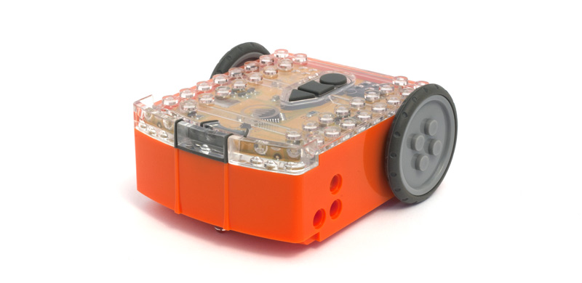
These lesson plans have been produced in conjunction with RoboticsWPS
www.roboticswps.com.au

Contents
Meet Robotics WPS 4
Summary 5
Lesson plan overview 6
LESSON 1: GET familiar and set up 9
Lesson 1 Worksheet 1.1 – Meet Edison 16
Lesson 1 Worksheet 1.2 – Barcode programming 17
Lesson 1 Worksheet 1.3 – Meet EdWare 18
Lesson 1 Worksheet 1.4 – Downloading a test program 19
LESSON 2: Robot movement – driving 20
Lesson 2 Worksheet 2.1 – Drive the robot forward 21
Lesson 2 Worksheet 2.2 – Drive the robot backward 22
Lesson 2 Worksheet 2.3 – Forward and then backward 23
Lesson 2 Worksheet 2.4 – Speed play 24
Lesson 2 Activity sheet 2.1 25
LESSON 3: Robot movement – turning 26
Lesson 3 Worksheet 3.1 – Right turn 90 degrees 27
Lesson 3 Worksheet 3.2 – Left turn 180 degrees 28
Lesson 3 Worksheet 3.3 – Right turn, then left turn 29
Lesson 3 Worksheet 3.4 – Mini maze 30
Lesson 3 Activity sheet 3.1 – Turning 31
Lesson 3 Activity sheet 3.2 – Mini maze 32
LESSON 4: Maze challenge and Mexican wave 33
Lesson 4 Worksheet 4.1 – Challenge 34
Lesson 4 Worksheet 4.2 – Mexican wave 35
Lesson 5: Design brief 1 – My program 36
Lesson 5 Design brief worksheet 5.1 – My program 37
Lesson 5 Design brief worksheet 5.2 – My program 38
Lesson 6: Clap sensing 39
Lesson 6 Worksheet 6.1 – Flash LED in response to clap 40
Lesson 6 Worksheet 6.2 – Drive in response to a clap 41
Lesson 6 Worksheet 6.3 – Dance in response to clapping 42
Lesson 7: Detect obstacles 43
Calibrate obstacle detection 44
Lesson 7 Worksheet 7.1 – Infrared obstacle detection 45
Lesson 7 Worksheet 7.2 – Detect obstacle and stop 46
Lesson 7 Worksheet 7.3 – Detect obstacle and avoid 47
Lesson 7 Worksheet 7.4 – Obstacle avoidance 48
Lesson 7 Worksheet 7.5 – Right and left detection 49
Lesson 8: Line sensing and tracking 50
Lesson 8 Worksheet 8.1 – Line tracking sensor 51
Lesson 8 Worksheet 8.2 – Drive until a black line 52
Lesson 8 Worksheet 8.3 – Drive inside a border 53
Lesson 8 Worksheet 8.4 – Follow a line 54
Lesson 8 Activity sheet 8.1 – Line tracking sensor 55
Lesson 8 Activity sheet 8.2 – Line tracking sensor 56
Lesson 9: Respond to light 57
Lesson 9 Worksheet 9.1 – Understanding variables 58
Lesson 9 Worksheet 9.2 – Light alarm 59
Lesson 9 Worksheet 9.3 – Automatic lights 60
Lesson 9 Worksheet 9.4 – Light following 61
Lesson 10: Design brief 2 – My program 62
Lesson 10 Design brief worksheet 10.1 – My program 63
Lesson 10 Design brief worksheet 10.2 – My program 65
Student achievement chart 66

Meet Robotics WPS

Michele Miller is the director and founder of Robotics WPS, which began in 2009. Michele is a registered teacher in New South Wales and Queensland, Australia, a lecturer at the University of Technology, Sydney (UTS) INSEARCH and has over 20 years of teaching experience.
In 2010, while teaching in NSW, she was invited to coordinate the robotics program at UTS INSEARCH in Sydney. Since then the team at Robotics WPS has developed a series of coding workshops and are now delivering robotics and programing workshops to Australian schools. Each year over 5,000 students are exposed to or involved in Robotics WPS workshops.
Robotics WPS also provides hands on help to schools, providing staff development days and incursion workshops.

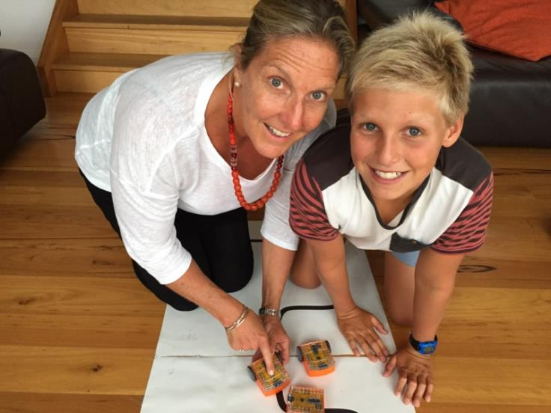
Michele Miller of Robotics WPS and a keen robotics student

Summary
These lessons have been designed and tested in workshops held by Robotics WPS over the past five years using a variety of robots. They have now been tested with the Edison robot and have proven to be very successful.
You can use these lesson plans either as they are or as a starting point to develop your own customised plans. Some teachers may need to make small changes to suit the abilities of their students. The lessons begin with the easier programming icons, such as basic movement behaviours and end with the class favourites, such as line tracking and sumo wrestling.
Students of all ages really enjoy the programming process, problem solving and collaboration involved with these lesson plans.
You will find that some students will grasp the initial concepts easily and be ready for the next activity. These lesson plans allow for independent learning and transition to the next lesson. As you grow in confidence with Edison and these lesson plans you will develop your own awareness of how best to transition your students from lesson to lesson.

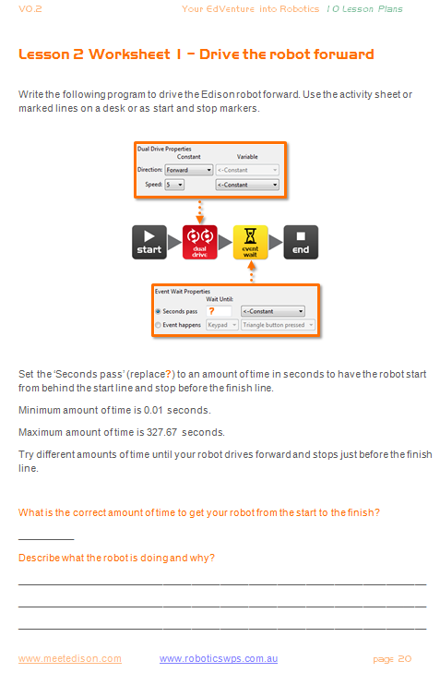
Worksheets
A number of worksheets have been provided for each lesson. The Worksheets allow students to work independently as they include instructions for student to follow.
The Worksheets also include questions for the students to answer that reinforce and demonstrate their learning.
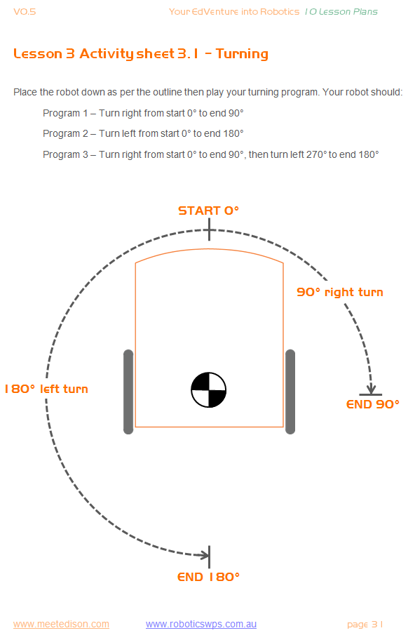

Activity sheets
Some of the lessons include Activity sheets. The Activity sheets provide students with a working area to quickly test their programs and run experiments.

Lesson plan overview
Most lessons have been designed to be completed in 90 minutes; however this will vary based on a student’s age and ability. All lesson plans have been linked to the Australian curriculum. Please see a complete list of references at meetedison.com/.

Lesson 1: Get familiar and set up
Technology skills – Students familiarise themselves with the programming environment and how to download a program to the robot.
1. Set up and become familiar with Edison using barcode programs
2. Open software and become familiar with how to move icons
3. Download test program

Lesson 2: Robot movement – driving
Introduction to sequential programming – Students learn how the robot responds to command icons and bring together the concepts of time, speed and distance.
Program 1 – Drive the robot forward (Worksheet 2.1)
Program 2 – Drive the robot backward (Worksheet 2.2)
Program 3 – Drive the robot forward and backward (Worksheet 2.3)
Program 4 – Speed play (Worksheet 2.4)

Lesson 3: Robot movement – turning
Sequential programing and basic geometry – Students learn how the robot responds to time and geometry and how they can achieve driving control of the robot.
Program 1 – Right turn (Worksheet 3.1)
Program 2 – Left turn (Worksheet 3.2)
Program 3 – Right and then left turn (Worksheet 3.3)
Program 4 – Mini maze (Worksheet 3.4)

Lesson 4: Maze challenge and Mexican wave
Reinforce learning – Students use knowledge from lessons 1 through 3 to achieve two fun open ended activities.
Program 1– Driving challenge (Worksheet 4.1)
Program 2 – Mexican wave robot style (Worksheet 4.2)

Lesson 5: Design brief 1 – My program
Creative thinking and problem solving – Students come up with their own challenge and conceptualise how the robot can provide a solution. Students may select their own topic, state the program’s purpose and explain where it could be used in the real world.
1. Identify a problem that the robot can solve or a fun movement to music
2. Describe the problem or the movements the robot needs to make
3. Write the program and test it
4. Failure – The first attempt is never successful. Document it and Keep trying!
5. Describe the programming icons used and what they do
6. Demo – Students demonstrate their robot’s program to the class

Lesson 6: Clap sensing
Introduction to inputs (sensors) – Students learn how to make the robot respond to outside stimulus (claps). This lesson also includes a fun class activity.
Program 1 – Flash LED in response to a clap (Worksheet 6.1)
Program 2 – Drive in response to a clap (Worksheet 6.2)
Program 3 – Dance in response to clapping (Worksheet 6.3)

Lesson 7: Detect obstacles
Introduction to the concept of obstacle detection and artificial intelligence – Students program the robot to make decisions (artificial intelligence) in response to obstacles in the robot’s environment.
Understanding infrared obstacle detection (Worksheet 7.1)
Program 1 – Detect an obstacle and stop (Worksheet 7.2)
Program 2 – Detect an obstacle and avoid (Worksheet 7.3)
Program 3 – Detect an obstacle and avoid in a loop (Worksheet 7.4)
Program 4 – Right and left obstacle detection (Worksheet 7.5)

Lesson 8: Line sensing and tracking
Industrial like robotic behaviour – Students learn about basic robot sensing and control similar to that used in advanced automated factories and warehouses.
Understanding the line tracking sensor (Worksheet 8.1)
Program 1 – Drive until a black line (Worksheet 8.2)
Program 2 – Drive inside a border (Worksheet 8.3)
Program 3 – Follow a line (Worksheet 8.4)
Video – Humans need not apply

Lesson 9: Respond to light
Environmental measurement and programming mathematics – Students learn about measuring light levels, storing them in memory and performing mathematics to control the robots behaviour.
Understanding variables (Worksheet 9.1)
Program 1 – Light level alarm (Worksheet 9.2)
Program 2 – Automatic lights (Worksheet 9.3)
Program 3 – Light following (Worksheet 9.4)
Animal behaviours in robotics

Lesson 10: Design brief 2 – My program
Creative thinking and problem solving – This is the second design brief where students come up with their own challenge and conceptualise how the robot can provide a solution
1. Identify a problem that the robot can solve or action it can take
2. Describe the problem or the action the robot needs to make
3. Write the program and test it
4. Failure – The first attempt is never successful. Document it and Keep trying!
5. Describe the programming icons used and what they do
6. Demo – Students demonstrate their robot’s program to the class

Relevance to NAPLAN testing (Australian national student testing)

Students find robotics highly engaging which assists in rapid learning in areas such as science, technology, engineering and maths (STEM). However there are other educational elements can be leveraged from this high level of engagement.
Throughout the lesson plans students provide written responses to describe their programs and the actions that their robots take. In the design brief worksheets students get to plan and create their own programs. They also write descriptive behaviours for icons used in their program.
The experience of Robotics WPS has shown that most students struggle with taking information from a visual stimulus and transferring it to written text.
These lesson plans, assist students with written responses from visual stimulus being a picture, graph or chart. This is a critical skill that is assessed in NAPLAN testing.
This is one of the areas where Robotics WPS has seen huge improvements in student’s developing their ability and understanding of how to transfer the acquired knowledge of their programs to written text.
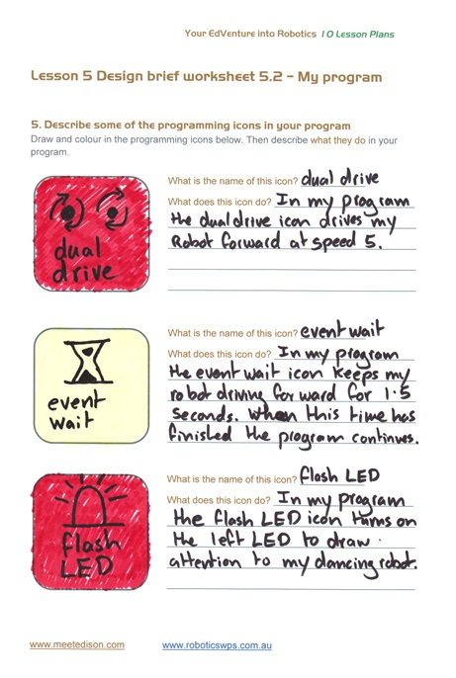
Example of a completed design brief worksheet

LESSON 1: GET familiar and set up
Technology skills – Students familiarise themselves with the programming environment and how to download a program to the robot.
Before we can use Edison we need to get a few things ready.
1. Get Edison ready
2. Get to know Edison
3. Install Edison’s software ‘EdWare’
4. Check that everything is working by downloading a test program

Get Edison ready
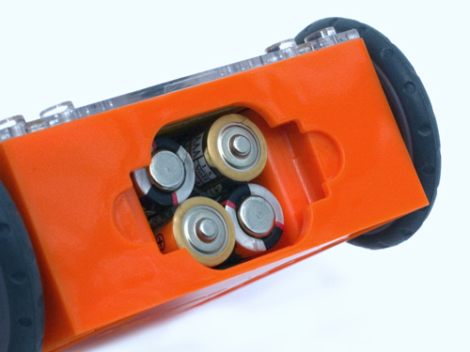
Ensure the batteries are the right way
Open the battery compartment and remove the programming cable. Now insert 4 ‘AAA’ batteries. Refer to the image to ensure that the batteries are the correct way around and clip the battery cover on.

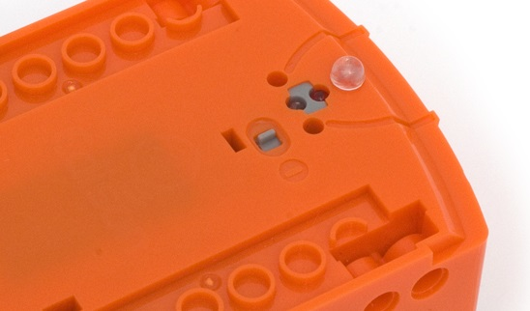
Push the switch towards the on symbol

Turn Edison on by sliding the power switch to the on position. Edison’s red LED lights will now start flashing.
Edison is ready to go!

Meet Edison (Worksheet 1.1)
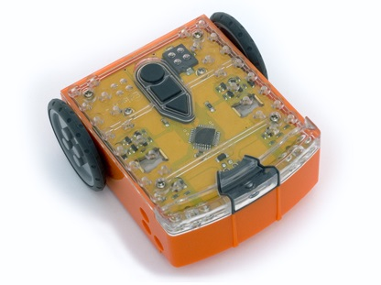
Students will need to be familiar with Edison and know where all the sensors are and what the three buttons do. Have students review the images in Worksheet 1. It may be worthwhile having this Worksheet available for students to review through the 10 lessons.
Buzzer/clap detector
Record button
Stop button
Play button
Left light sensor
Left infrared LED
Left red LED
Right light sensor
Right infrared LED
Right red LED
Get to know Edison’s sensors and buttons

Play button – Start program
Stop button – Press to stop a program
Record button – 1 press = download program, 3 presses = read barcode
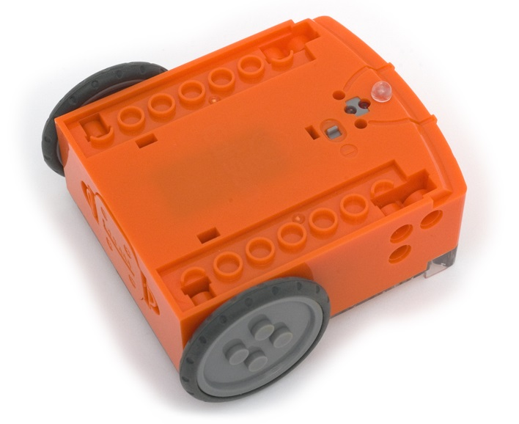
Line tracking sensor
Power switch
Edison’s power switch and line tracking sensor
Edison’s line tracking sensor is made up of two parts a red LED light and a light sensor.
The line tracking sensor also reads special barcodes that activate pre-installed programs.

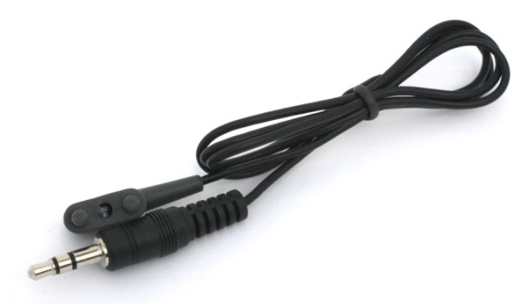
EdComm programming cable
The EdComm cable is used to download your programs to Edison. It connects into the headphone socket on your computer or tablet.

Installing EdWare
The EdWare programming software is available for Windows, Mac, Linux, iOS, Android and Raspberry Pi. Point your internet browser to meetedison.com/downloads to obtain the installation files and instructions on how to install EdWare for your operating system.

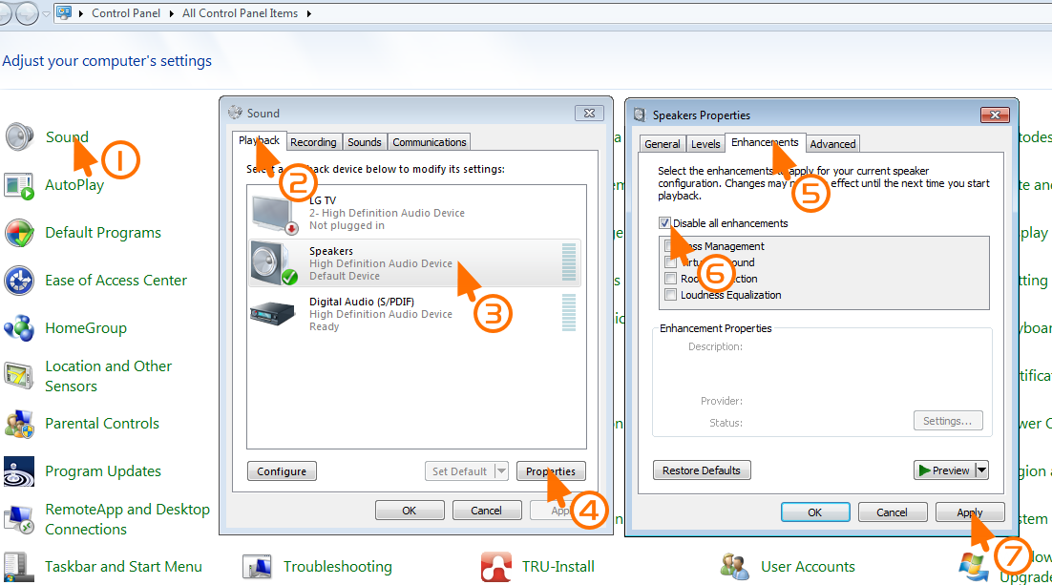
For Windows operating systems sound enhancements must be disabled. Follow these steps to disable all enhancements.
How to disable all enhancements in Windows 7

Barcode programming (Worksheet 1.2)
To get students excited about robotics and what they will learn, hand out worksheet 2 with the robots. The worksheet includes four barcodes that Edison can scan.
Have the students scan each barcode and describe to them how they work and the sensors that they use.

Clap controlled driving
Place Edison down on a flat surface and press the play (triangle) button. Now clap your hands close to Edison. He will turn to his right. Now clap your hands twice and Edison will drive forward about 30cm. Also, try tapping Edison with your finger, once and then twice.
Edison has a sound sensor and uses it to responds to claps.

Avoid obstacles
Press the play (triangle) button and watch Edison approach an obstacle and then turn away to avoid colliding with it. Edison is using infrared light to detect obstacles in his path.

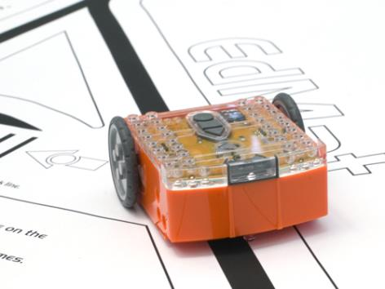
Line tracking
Edison line following
Place Edison to one side of your line, (1.5cm/0.6in wide) so that the line tracking sensor is on white. Now press the play (triangle) button and watch Edison follow the line.
Edison’s line tracking sensor shines light on the surface and then measures the amount of light that is reflected back. White reflects a lot of light, giving a high light reading and black reflects very little, giving a low light reading.
To track the line Edison is in a constant state of dissatisfaction. When he is off the line, he turns right to get on the line. But when he’s on the line, he turns left to get off the line. This results in him waddling on the edge of the line.

Follow torch
You will need a torch/flashlight and a flat surface away from any really bright light, such as sun light. Press the play button and aim the torch at Edison. Once he ‘sees’ the bright source of light he will drive towards it. By moving the torch you can control where Edison drives to. Does this behaviour remind you of anything?
This is one of Edison’s most interesting programs, because it mimics the behaviour we see in some flying insect. I’m sure you’ve seen moths on a hot summer night swarming around a bright light. This type of robotic behaviour is called ‘phototropism’ and is found in plants that grow towards the sun.

Meet EdWare (Worksheet 1.3)
Once the students are excited and motivated from their interactions with Edison they can start using EdWare.
To gain familiarity, have students open the software and start moving the icons from the icon palette on the left and placing them in the program area. There is no need to make a working program at this stage.
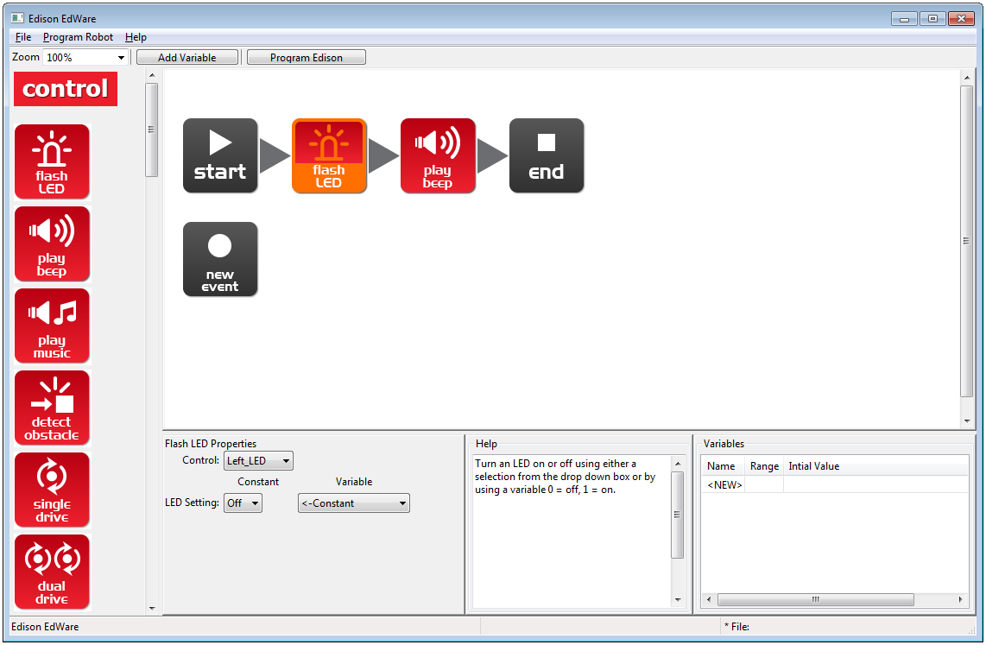
Here is what EdWare for Windows looks like. EdWare for the other operating systems looks very similar.
Icon palette
A simple two icon program
Icon is selected and can be edited
Programming area
Icon properties box
Icon help text
Variables

To start programming, grab icons from the palette on the left and drag them onto the programming area. Place the icons between the ‘start’ and ‘end’ icons.
Select an icon and adjust the settings in the icon property box to control how Edison responds to that icon.
Use the help text as a guide while programming. Everything you need to know about an icon can be found here.
The variables section is where you can create and view little pieces of Edison’s memory. More on this in lesson 9.

Test program (Worksheet 1.4)
The students can now open the test program.
File name: Test Program.edw (Windows location: C:\Program Files\EdWare\My Programs)
The test program looks like this:

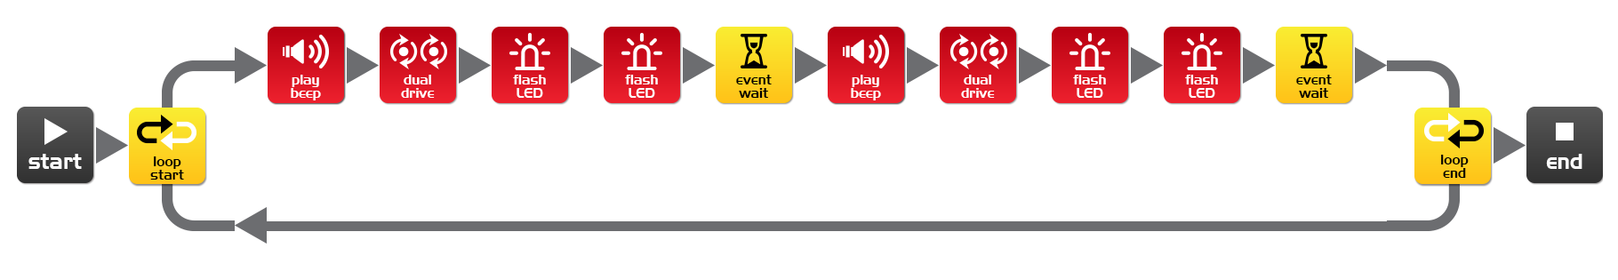
Test program

Explain to the students this is what a program looks like. Edison looks at each icon one at a time and does what the icon says. The arrows show the direction that Edison reads the icons. In this program there is a loop, so the program loops around forever or until the batteries go flat.
The students can now download the test program to their robots.
Connect the EdComm cable to the headphone socket on the computer or tablet and turn up the volume to full. Plug the other end of the EdComm cable into Edison as shown.

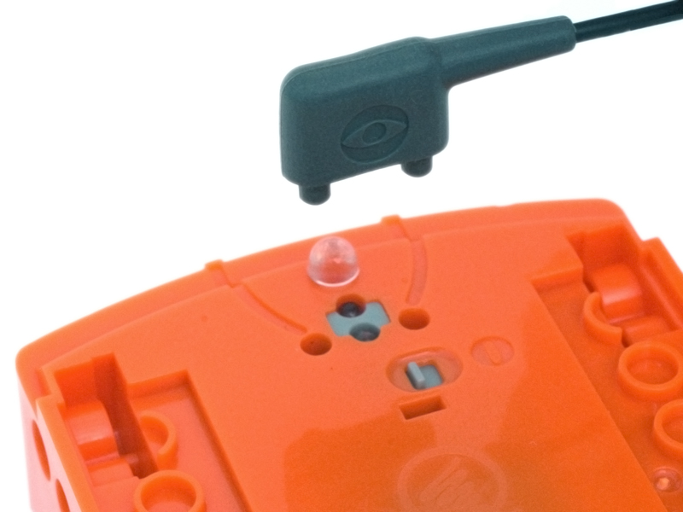

To download the test program follow these steps:
1. Press Edison’s record (round) button once
2. In EdWare press the ‘Program Edison’ button and then ‘Start Download’
3. Press Edison’s play (triangle) button to start the program
Edison will now run the test program and spin left and right, flashing his lights and beeping.

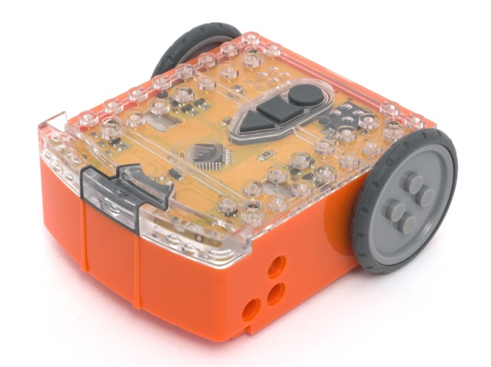

Explain to the students that the robot reads each icon one by one and in the sequence shown by the arrows. Each icon tells the robot what to do.

Also explain to the students that the program goes from the computer/tablet through the cable to the Edison robot. The cable converts the sounds from the headphone jack into light, which the robot receives and stores the program in its memory.

Lesson 1 Worksheet 1.1 – Meet Edison
Name: ________________________
Edison is a small LEGO compatible and programmable robot.
Edison uses sensors and motors to interact with the world. In the images below you can see Edison’s sensors, buttons and switches.
Buzzer/clap detector
Record button
Stop button
Play button
Left light sensor
Left infrared LED
Left red LED
Right light sensor
Right infrared LED
Right red LED
Get to know Edison’s sensors and buttons

Play button – Start program
Stop button – Press to stop a program
Record button – 1 press = download program, 3 presses = read barcode
Line tracking sensor
Power switch
Edison’s power switch and line tracking sensor
Edison’s line tracking sensor is made up of two parts a red LED light and a light sensor.
The line tracking sensor also reads special barcodes that activate pre-installed programs.

EdComm programming cable
The EdComm cable is used to download your programs to Edison. It connects into the headphone socket on your computer or tablet.
www.meetedison.com

Lesson 1 Worksheet 1.2 – Barcode programming
Name: ________________________

Reading the barcode
1. Place Edison facing the barcode on the right side
2. Press the record (round) button 3 times
3. Edison will drive forward and scan the barcode
Describe the actions that the robot takes and why for each barcode
___________________________
___________________________
___________________________
___________________________

___________________________
___________________________
___________________________
___________________________

___________________________
___________________________
___________________________
___________________________

___________________________
___________________________
___________________________
___________________________
___________________________

Barcode - Clap controlled driving

Barcode – Avoid obstacles

Barcode – Line tracking

Barcode – Follow torch

www.meetedison.com

Lesson 1 Worksheet 1.3 – Meet EdWare
Name: ________________________
This is EdWare and is the software used to program the Edison robot.
Icon palette
A simple two icon program
Icon is selected and can be edited
Programming area
Icon properties box
Icon help text
Variables

To get familiar with EdWare and programming, grab icons from the palette on the left and drag them onto the programming area. Place the icons between the ‘start’ and ‘end’ icons.
Select an icon and adjust the settings in the icon property box to control how Edison responds to that icon. Use the help text as a guide while programming. Everything you need to know about an icon can be found here. The variables section is where you can create and view little pieces of Edison’s memory.
What are the names of the four major icon groups?
______________
______________
______________
______________
www.meetedison.com

Lesson 1 Worksheet 1.4 – Downloading a test program
Name: ________________________

Open the test program. File name: Test Program.edw (Windows location: C:\Program Files\EdWare\My Programs)
Test program
This is what a program looks like. Edison looks at each icon one at a time and does what the icon says. The arrows show the direction that Edison reads the icons. In this program there is a loop, so the program loops around forever or until the batteries go flat.
To download the test program connect the EdComm cable to the headphone socket on the computer or tablet and turn up the volume to full. Plug the other end of the EdComm cable into Edison as shown.

To download the test program follow these steps:
1. Press Edison’s record (round) button once
2. In EdWare press the ‘Program Edison’ button and then ‘Start Download’
3. Press Edison’s play (triangle) button to start the program

What did the robot do when you pressed the play button?
________________________________________________________________________
________________________________________________________________________
Can you relate these actions to the icons in the program? Please describe your thoughts.
________________________________________________________________________
________________________________________________________________________
How did the program get from the computer to the robot?
________________________________________________________________________
________________________________________________________________________
www.meetedison.com

LESSON 2: Robot movement – driving
Introduction to sequential programming – Students learn how the robot responds to command icons in sequence and bring together the concepts of time, speed and distance.
In this lesson students will use the basic control drive icons to drive the robot forward and backward a set distance.

Program 1 – Drive the robot forward (Worksheet 2.1)
Using either the worksheet or coloured tape on a desk, instruct the students to write a program that drives the robot forward a set distance from a start marker to a stop marker. The robot must stop before driving over the marker.

Program 2 – Drive the robot backward (Worksheet 2.2)
Using either the worksheet or coloured tape on a desk, instruct the students to write a program that drives the robot backward a set distance from a start marker to a stop marker. The robot must stop before driving over the marker.

Program 3 – Drive the robot forward and backward (Worksheet 2.3)
Using either the worksheet or coloured tape on a desk, instruct the students to write a program that drives the robot forward and then backward a set distance from a start marker to a stop marker and then back again.

Program 4 – Speed play (Worksheet 2.4)
Ask the students to experiment with speed, time and distance.
Students can create their own start and stop markers.
What is the quickest time that the robot can travel to the stop marker and back?
What is the slowest time that the robot can travel to the stop marker and back?
For student creativity they can add beeps and flashing LED lights to their program.
Each worksheet asks students to describe what the robot is doing and why. A typical answer may look like:
The robot drives forward because the program has a drive icon that states forward. It drives to the finish line and stops because the time in the event wait icon is 0.35 seconds and this is how long it takes the robot to drive that far.
www.meetedison.com

Lesson 2 Worksheet 2.1 – Drive the robot forward
Name: ________________________
Name: ________________________

Write the following program to drive the Edison robot forward. Use the activity sheet or coloured tape on a desk as start and stop markers.
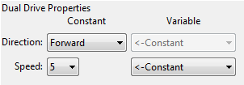
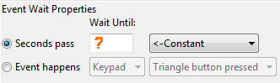

Set the ‘Seconds pass’ (replace?) to an amount of time in seconds to have the robot start from behind the start line and stop before the finish line.
Minimum amount of time is 0.01 seconds.
Maximum amount of time is 327.67 seconds.
Try different amounts of time until your robot drives forward and stops just before the finish line.

What is the correct amount of time to get your robot from the start to the finish?
__________
Describe what the robot is doing and why?
________________________________________________________________________
________________________________________________________________________
________________________________________________________________________
www.meetedison.com

Lesson 2 Worksheet 2.2 – Drive the robot backward
Name: ________________________

Write the following program to drive the Edison robot backwards. Use the activity sheet or coloured tape on a desk as start and stop markers.
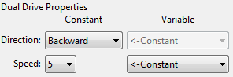

Set the ‘Seconds pass’ (replace?) to an amount of time in seconds to have the robot start from behind the start line and stop before the finish line.
Minimum amount of time is 0.01 seconds.
Maximum amount of time is 327.67 seconds.
Try different amounts of time until your robot drives backwards and stops just before the finish line.

What is the correct amount of time to get your robot from the start to the finish?
__________
Describe what the robot is doing and why?
________________________________________________________________________
________________________________________________________________________
________________________________________________________________________
www.meetedison.com

Lesson 2 Worksheet 2.3 – Forward and then backward
Name: ________________________

Write the following program to drive the Edison robot forward and then backward. Use the activity sheet or coloured tape on a desk as start and stop markers.

Set the ‘Seconds pass’ (replace?) to an amount of time in seconds to have the robot start from behind the start line and stop before the finish line, then drive backwards and stop before the start line.
Minimum amount of time is 0.01 seconds.
Maximum amount of time is 327.67 seconds.
Try different amounts of time until your robot drives forwards and backwards and stops just before the start line.

What are the correct times to drive forward and backward?
Forward __________ Backward __________
Describe what the robot is doing and why?
________________________________________________________________________
________________________________________________________________________
________________________________________________________________________
www.meetedison.com

Lesson 2 Worksheet 2.4 – Speed play
Name: ________________________

Write the following program to drive the Edison robot forward and then backward. Use the activity sheet or marked lines on a desk as start and stop markers.
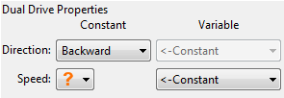
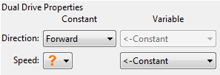

This time change the time and the speed!
Feel free to add new icons to your program such as play beep, flash LED or even play music.

1. Start from behind the start line and stop before the finish line, then drive backwards and stop before the start line as fast as possible!
What are your fastest settings?
Drive forward speed ________ Drive forward time ________
Drive backward speed _________ Drive backward time _______

2. Start from behind the start line and stop before the finish line, then drive backwards and stop before the start line as slow as possible!
What are your slowest settings?
Drive forward speed ________ Drive forward time ________
Drive backward speed _________ Drive backward time _______
www.meetedison.com

Lesson 2 Activity sheet 2.1
Name: ________________________
FINISH LINE
START LINE

www.meetedison.com

LESSON 3: Robot movement – turning
Sequential programing and basic geometry – Students learn how the robot responds to time and geometry and how they can achieve driving control of the robot.
In this lesson students will use the basic control drive icons to turn the robot at different angles (90°, 180° and 270°) and then using learning from lesson 2 create a driving sequence.

Program 1 – Right turn (Worksheet 3.1)
Using either Activity sheet 3.1 or coloured tape on a desk, instruct the students to write a program that turns the robot right 90 degrees.

Program 2 – Left turn (Worksheet 3.2)
Using either worksheet 3.1 or coloured tape on a desk, instruct the students to write a program that turns the robot left 180 degrees.

Program 3 – Right and then left turn (Worksheet 3.3)
Using either worksheet 3.1 or coloured tape on a desk, instruct the students to write a program that turns the robot 90 degrees right then 270 (90 + 180) degrees left.

Program 4 – Mini maze (Worksheet 3.4)
Using either worksheet 3.2 or coloured tape on a desk, instruct the students to write a program that can navigate a mini maze. Students will use the learning from lesson 2 and 3 to complete this challenge.

Each worksheet asks students to describe what the robot is doing and why. A typical answer may look like:
The robot turns because the program has a drive icon that states spin left. It turns 90 degrees because the time in the event wait icon is 0.35 seconds and this is how long it takes the robot to turn that far.

Lesson 3 Worksheet 3.1 – Right turn 90 degrees
Name: ________________________

Write the following program to turn the Edison robot right 90 degrees (90°). Use Activity sheet 3.1 or marked lines on a desk as start and stop markers.
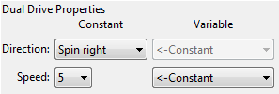

Set the ‘Seconds pass’ (replace?) to an amount of time in seconds to have the robot turn right exactly 90°.
Minimum amount of time is 0.01 seconds.
Maximum amount of time is 327.67 seconds.
Try different amounts of time until your robot turns right from the start point to the end point.

What is the correct amount of time to get your robot to turn 90°?
__________
Describe what the robot is doing and why?
________________________________________________________________________
________________________________________________________________________
________________________________________________________________________
www.meetedison.com

Lesson 3 Worksheet 3.2 – Left turn 180 degrees
Name: ________________________

Write the following program to turn the Edison robot left 180 degrees (180°). Use Activity sheet 3.1 or marked lines on a desk as start and stop markers.
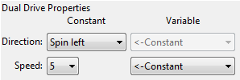

Set the ‘Seconds pass’ (replace ?) to an amount of time in seconds to have the robot turn left exactly 180°.
Minimum amount of time is 0.01 seconds.
Maximum amount of time is 327.67 seconds.
Try different amounts of time until your robot turns left from the start point to the end point.

What is the correct amount of time to get your robot to turn 180°?
__________
Describe what the robot is doing and why?
________________________________________________________________________
________________________________________________________________________
________________________________________________________________________
www.meetedison.com

Lesson 3 Worksheet 3.3 – Right turn, then left turn
Name: ________________________

Write the following program to turn the Edison robot right 90 degrees (90°) and then left 180 degrees (180°). Use Activity sheet 3.1 or marked lines on a desk as start and stop markers.

Set the ‘Seconds pass’ (replace?) to an amount of time in seconds to have the robot turn right exactly 90° and then left 270° (90° + 180°) degrees.
Minimum amount of time is 0.01 seconds.
Maximum amount of time is 327.67 seconds.
Try different amounts of time until your robot turns 90° right from the start point to the end point and then left 270° to the bottom end point.

What is the correct amount of time to get your robot to turn 90°, then 270°?
90°: _______, 270°: _________
Describe what the robot is doing and why?
________________________________________________________________________
________________________________________________________________________
________________________________________________________________________
www.meetedison.com

Lesson 3 Worksheet 3.4 – Mini maze
Name: ________________________

Use the robot programming knowledge that you’ve gained to dive your Edison robot through the mini maze on Activity sheet 3.2.
The robot must start from behind the start line and stop after the finish line and must not drive on the lines.
You will need to combine multiple programming icons to drive the robot forward and make the required turns.

Hint: Forward, spin right, forward, spin left, forward

Describe what the robot is doing and why?
________________________________________________________________________
________________________________________________________________________
________________________________________________________________________

What challenges did you encounter getting the robot to drive the maze?
________________________________________________________________________
________________________________________________________________________

Advanced competition
Who can get the fastest time through the maze?
There is no need to use a stopwatch. Just add up the time in all the event wait icons.
Remember: The robot must start from behind the start line and stop after the finish line and must not drive on the lines to win.

What’s your robot’s time through the maze?
_________
www.meetedison.com

Lesson 3 Activity sheet 3.1 – Turning
Name: ________________________

Place the robot down as per the outline then play your turning program. Your robot should:
Program 1 – Turn right from start 0° to end 90°
Program 2 – Turn left from start 0° to end 180°
Program 3 – Turn right from start 0° to end 90°, then turn left 270° to end 180°

END 180°
START 0°
90° right turn
END 90°
180° left turn

www.meetedison.com

Lesson 3 Activity sheet 3.2 – Mini maze
Name: ________________________
START LINE
FINISH LINE

www.meetedison.com

LESSON 4: Maze challenge and Mexican wave

Reinforce learning – Students use knowledge from lessons 1 through 3 to achieve two fun open ended activities.
In this lesson students complete two programming activities.

Program 1– Driving challenge
Students choose a driving challenge for their robot and then write a program for it. Some examples are:
- Drive around an obstacle, such as a cup or pencil case
- Drive around the border of a desk without driving off the edge
- Create a maze on a large piece of paper for the robot to drive through
- Create a maze using building blocks for the robot to drive through

Program 2 – Mexican wave robot style
This is a fun class activity that has everyone’s robot executing the same program at a slightly different time. The result is similar to a Mexican wave or choreographed dance.
Students write a short program with a ‘cool’ sequence of robot moves. They are also encouraged to use light and sound in their programs.
The class (or teacher) selects the program with the best/’coolest’ set of moves. This program is then shared with all other students. Each student then adds an event wait icon to the beginning of the program.
To form a Mexican wave effect each student programs a slightly different time into the new event wait icon. For example:
Robot 1 – Event wait time 0 seconds
Robot 2 – Event wait time 0.2 seconds
Robot 3 – Event wait time 0.4 seconds
Robot 4 – Event wait time 0.6 seconds
Robot 5 – Event wait time 0.8 seconds
Robot 6 – Event wait time 1.0 seconds
Robot 7 – Event wait time 1.2 seconds
Robot 8 – Event wait time 1.4 seconds
Robot 9 – Event wait time 1.6 seconds
Robot 10 – Event wait time 1.8 seconds
Robots 1 through 10 are placed in a line in order of their delay time. Everyone then presses play at the same time and stands back to watch the performance.
Note: Apple do not allow for importing of files in iOS, so this activity might not be possible if you use iPads.

Lesson 4 Worksheet 4.1 – Challenge
Name: ________________________

Choose a robot driving challenge for yourself and program your Edison robot to drive that challenge.
Here are some examples, but you can come up with your own challenge.
- Drive around and obstacle, such as a cup or pencil case
- Drive around the border of a desk without driving off the edge
- Create a maze on a large piece of paper
- Create a maze using building blocks such as LEGO

Remember that you can use other programming icons such as flash LED, play beep and play music to be creative.

What is your robot driving challenge?
________________________________________________________________________
________________________________________________________________________
________________________________________________________________________

What was difficult about writing this program?
________________________________________________________________________
________________________________________________________________________
________________________________________________________________________

What additional programming icons did you include in your program and what did they do?
________________________________________________________________________
________________________________________________________________________
________________________________________________________________________

www.meetedison.com

Lesson 4 Worksheet 4.2 – Mexican wave
Name: ________________________

This is a fun class activity that has everyone’s robot executing the same program at a slightly different time. The result is similar to a Mexican wave or choreographed dance.

Loops
Use a loop in your program so that the movements repeat.
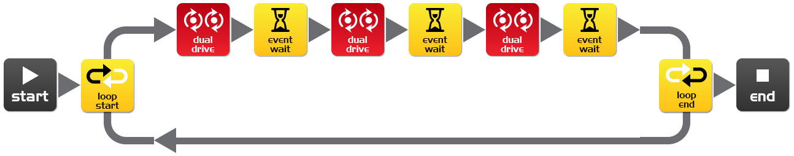
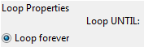

What you need to do:
Write a short program with a ‘cool’ sequence of robot moves. Don’t forget to use light and sound in your program.
When you’ve written your sequence of moves and tested it have the teacher review and pick the best one from the class.
If yours is picked share your program file with the class. If someone else’s program is picked, when you open their program file add an event wait icon at the beginning. Set the time as the teacher says.
Event wait icon time: __________ Robot number: __________ (for placing robots in order)
Place all the robots in a line in order of delay time with the shortest at the beginning and longest at the end. Everybody now presses play at the same time.
Now stand back and watch the robot performance.

Describe your robots cool moves
________________________________________________________________________
________________________________________________________________________
________________________________________________________________________
www.meetedison.com

Lesson 5: Design brief 1 – My program
Creative thinking and problem solving – Students come up with their own challenge and conceptualise how the robot can provide a solution. This may take two lesson periods; alternatively this can be a home work exercise. Students may select their own topic, state the program’s purpose and explain where the program could be used in the real world.

1. Identify a problem that the robot can solve or a fun movement to music
In the future robots will be our helpers. We already have robot vacuum cleaners, so this future isn’t too far away. What helpful or entertaining task can a student’s robot perform?
Examples are:
- Dance to music – robot dances to the student’s favourite music
- Vacuum cleaner – students can draw a living room floor layout on a large piece of paper and program the robot to ‘vacuum’ the entire area
- Security robot – students can define a secure area (square drawn on paper or a small object. The robot’s job is to guard the secure area by driving around it.

2. Describe the problem or the movements the robot needs to make
Using the design brief worksheet students describe the problem that their robot program solves and how the robot program solves the problem.
Example: The problem is… ‘People can dance well, but their movements are slow and can be out of sync with other dancers.’ My robot will solve this by… ‘Making fast movements and by keeping in time with the other robots doing the same dance routine. This will be more entertaining to watch than people dancing.’

3. Write the program and test it
Students write their program and test it.

4. Failure
Inevitably, the first attempt is never successful. Some students may need extra encouragement to keep trying! Failure is a normal part of programming (or any engineering discipline). Thomas Edison famously failed 10,000 times before he succeeded at inventing the light bulb! The students can describe their failures on the design brief worksheet.

5. Describe the programming icons used and what they do
Using the design brief worksheet 5.2 students select a number of icons being used in their program and describe what the icon does in the program. Print additional sheets to have students describe more programming icons.

6. Demo
The students demonstrate their robot’s behaviour and talk about their idea, the program, the problems that they encountered and how they solved them.

Lesson 5 Design brief worksheet 5.1 – My program
Name: ________________________
In the future robots will be our helpers. We already have Roomba the robot vacuum cleaner, so this future isn’t too far away. Think of a useful task that your robot can perform, and then write a program for it to do that task.
Here are some examples:
- Dance to music – an entertainment robot
- Vacuum cleaner – very handy in the home
- Security robot – keep your pencil case safe

1. Discuss
Discuss this with your partner or other students to decide on a useful robot application that you can program.

2. Describe
Before you start writing your program describe below the problem that your robot is going to solve and how it is going to solve it.
The problem is…__________________________________________________________
________________________________________________________________________
________________________________________________________________________
My robot will solve this by…__________________________________________________
________________________________________________________________________
________________________________________________________________________

3. Write your program
Plan your program before you start to put icons into place. Use the icons that you have learned to use, but you may also try out other icons.

4. Failure?
Not everything works out the way you think it will first time. No sweat! Try again, but first describe what went wrong. Why didn’t your program work first time? Remember this: Thomas Edison famously failed 10,000 times before he successfully invented the light bulb! So, keep trying!
________________________________________________________________________
________________________________________________________________________
________________________________________________________________________
________________________________________________________________________
www.meetedison.com

Lesson 5 Design brief worksheet 5.2 – My program
Name: ________________________

5. Describe some of the programming icons in your program
Draw and colour in the programming icons below. Then describe what they do in your program.
www.meetedison.com
What is the name of this icon? _____________________
What does this icon do? __________________________
______________________________________________
______________________________________________
______________________________________________
______________________________________________

What is the name of this icon? _____________________
What does this icon do? __________________________
______________________________________________
______________________________________________
______________________________________________
______________________________________________

What is the name of this icon? _____________________
What does this icon do? __________________________
______________________________________________
______________________________________________
______________________________________________
______________________________________________

Lesson 6: Clap sensing
Introduction to inputs (sensors) – Students learn how to make the robot respond to outside stimulus (claps).
In this lesson students will learn about how a robot can sense outside stimulus and how to program the robot’s response and create robot behaviour.

Program 1 – Flash LED in response to a clap (Worksheet 6.1)
Students become familiar with programming the robot to wait for an event to occur before continuing the program. In this case the event is a loud sound such as a clap.

Program 2 – Drive in response to a clap (Worksheet 6.2)
Students now incorporate learning from previous lessons to drive the robot in response to an event (clap).

Program 3 – Dance in response to clapping (Worksheet 6.3)
Students create their own robot movements in response to clapping. They have two options:
1. Create a robot dance routine with multiple dance manoeuvres
2. Create a program that drives the robot through an obstacle course in response to claps

Fun class activity
Select the best dance routine and have all other students program their robot with it. Then place all the robots together and have the students clap in time to see all the robots dance together. You’ll need to count the claps in with 1, 2, 3, 4… Clapping starts at 5, and continues for 6, 7, 8…

Lesson 6 Worksheet 6.1 – Flash LED in response to clap
Name: ________________________

Write the following program to have the Edison robot flash the left LED in response to a loud sound such as a clap.
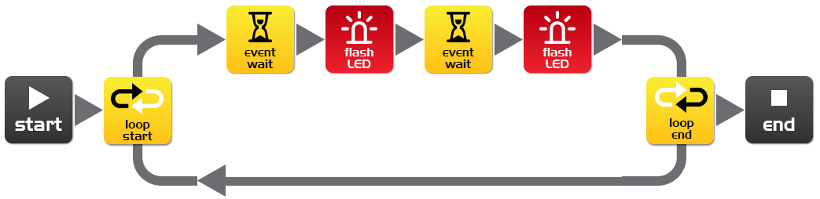
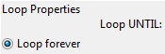
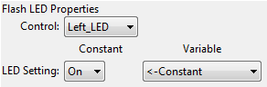
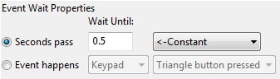
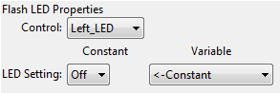
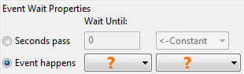

In this program the first event wait icon is not being used to wait for time. Instead the program will not continue from this point until a specific event occurs.
Within the first event wait icon’s properties box select the ‘Event happens’ radio button and then select the event type you think is required to respond to a clap.

What distance can the robot sense your claps?
__________

What is the purpose of the loop icons in this program and what would happen if the loop icons were not there?
________________________________________________________________________
________________________________________________________________________
________________________________________________________________________
www.meetedison.com

Lesson 6 Worksheet 6.2 – Drive in response to a clap
Name: ________________________

Write the following program to have the Edison robot drive forward in response to a clap.
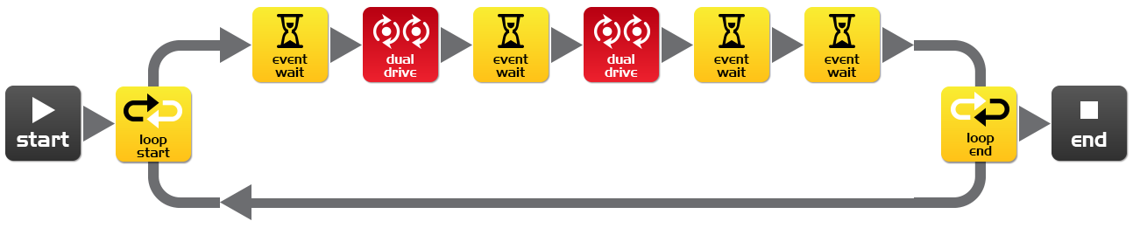
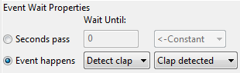
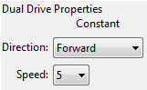
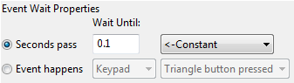
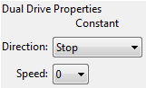

The Edison robot’s sound sensor is not just sensitive to claps, but can also respond to any loud sound. This includes the robot’s motors, gears and wheels, which also make sound as they turn. To prevent the sound of the robot driving from triggering the sound sensor there are two additional icons used in this program and are marked above with orange stars. The first event wait icon is set to 0.1 seconds and gives the robot’s motors time to stop. The second event wait icon is set to wait for a clap and will allow the program to continue, because it will have detected the sound of the motors.
You will need to use these two icons after stopping the motors if you are using the clap sensor.
Experiment with different directions in the first dual drive icon and with the following event wait icon to create different movements.
What other directions and times did you try?
Experiment 1: direction ___________, time____________
Experiment 2: direction ___________, time____________
Experiment 3: direction ___________, time____________
www.meetedison.com

Lesson 6 Worksheet 6.3 – Dance in response to clapping
Name: ________________________

Using what you have learned in the previous two exercises create a dance routine where the robot responds to your claps.
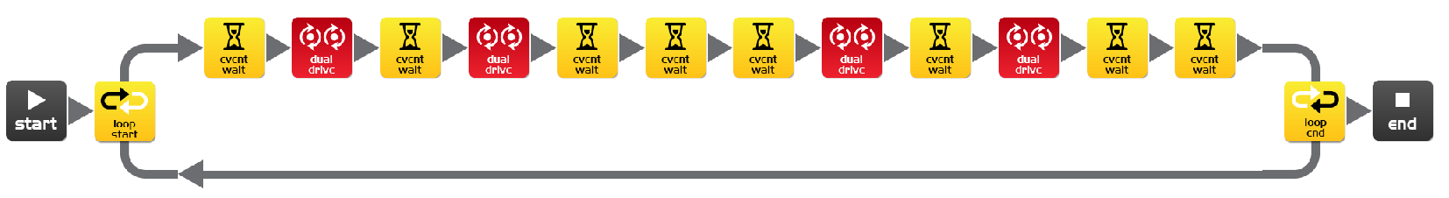
Manoeuvre 1
Manoeuvre 2

You will need at least two dance manoeuvres, but you can add as many as you like. The above program has two single action manoeuvres. These two manoeuvers repeat because they are in a loop.
You can also try and add two manoeuvres per clap.

Alternative challenge
If you don’t want to program a dance, then you could create a short obstacle course that the robot drives in response to a clap and then returns in response to a second clap.

How many manoeuvers does your program have?
__________

Describe your robot’s dance or drive manoeuvres.
________________________________________________________________________
________________________________________________________________________
________________________________________________________________________

Fun class activity
Select the best dance routine from the class, and have every student program their robot with it. Then place all the robots together and everyone clap in time to see the robots dance.
www.meetedison.com

Lesson 7: Detect obstacles
Introduction to the concept of obstacle detection and artificial intelligence – Students program the robot to make decisions (artificial intelligence) in response to obstacles in the robot’s environment.

Understanding infrared obstacle detection (Worksheet 7.1)
Students become familiar with the robot’s infrared obstacle detection technology and how the robot can detect obstacles in its path.

Program 1 – Detect an obstacle and stop (Worksheet 7.2)
Students write a program that drives the robot until an obstacle in its path is detected. The robot then stops, avoiding a collision.

Program 2 – Detect an obstacle and avoid (Worksheet 7.3)
Students write a program that drives the robot until an obstacle in its path is detected. The robot then turns away, avoiding a collision.

Program 3 – Detect an obstacle and avoid in a loop (Worksheet 7.4)
Students write a program that contains a continuous loop that drives the robot until an obstacle in its path is detected. The robot then turns away, avoiding a collision. The robot then continues to drive due to the loop looking for other obstacles to avoid.

Program 4 – Right and left obstacle detection (Worksheet 7.5)
Students write a program that contains a continuous loop and has the ability to respond to whether there is an obstacle on the left or right. To do this students use an ‘IF’ icon.
The significance of an IF icon is that it gives the robot the ability to make decisions without human guidance. When this occurs in a robot it is now called an autonomous robot, as it has artificial intelligence. This is a profound concept. Is the robot now alive!?

This lesson can also be used to stimulate discussion about robot cars that have no driver and use sensors to avoid collisions with people, buildings and other cars.
If the obstacle detection is too sensitive or not sensitive enough, students can recalibrate it using the instructions on the following page.

Calibrate obstacle detection
Name: ________________________
You can control the sensitivity of Edison’s obstacle detection system. By making it more sensitive he can detect obstacles further away, and by making it less sensitive he will only detect very close obstacles.

Reading the barcode
1. Place Edison facing the barcode on the right side
2. Press the record (round) button 3 times
3. Edison will drive forward and scan the barcode
Barcode – Calibrate obstacle detection

Set maximum sensitivity
First scan the above barcode, then press the play (triangle) button. Edison is now in calibration mode. Remove any obstacles in front of Edison.
The left sensitivity is calibrated first.
1. Repeatedly press the play button (this increses sensitivity) until the left red LED is flickering.
2. Repeatedly press the record (round) button (this decreases the sensitivity) until the LED completely stops flickering.
3. Press the stop (square) button to calibrate the right side.
4. Repeatedly press the play button until the right red LED is flickering. Now repeatedly press the record button until the LED completely stops flickering.
5. Press the stop button and the calibration is complete.

Custom sensitivity
You can set the distance that obstacles are detected by placing an obstacle in front of Edison and repeating steps 1 through 5.
www.meetedison.com

Lesson 7 Worksheet 7.1 – Infrared obstacle detection
Name: ________________________

The Edison robot is equipped with infrared (IR) ‘vision’. IR light is not visible to the human eye, so you can’t see this light, but it allows Edison to ‘see’ in the dark.
For Edison to detect obstacles IR light is emitted forward from the left and right side of the robot. If the IR light is reflected off an obstacle such as a wall, then the reflected light is detected by Edison’s single IR detector. The IR detector is in the front centre of the robot.
In the illustration below there is an obstacle to Edison’s left, so only IR light from the left emitter is reflected. From the received signal Edison can determine that there is an obstacle to the left, but no obstacle to the right.
Emitted IR light is shown in red and reflected IR light is shown in blue.
IR light emitter
IR light emitter
IR light detector

Draw the emitted IR light and reflected IR light for this obstacle.
IR light emitter
IR light emitter
IR light detector

www.meetedison.com

Lesson 7 Worksheet 7.2 – Detect obstacle and stop
Name: ________________________

Write the following program to have the Edison robot drive until it encounters an obstacle.
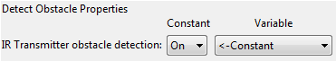
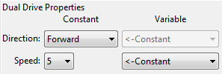
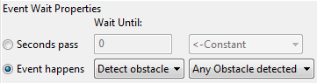

The red (control group) detect obstacle icon is required to turn the obstacle detection system on and starts the IR light emitters.
The dual drive speed is set to 5 to allow the robot to detect an obstacle before colliding with it. If the speed is too fast then the robot will crash into obstacles.

At what distance can the robot detect obstacles?
__________

Have you seen this type of invisible detection before and where?
________________________________________________________________________
________________________________________________________________________

Where else do you think this type of detection technology could be used?
________________________________________________________________________
________________________________________________________________________
www.meetedison.com

Lesson 7 Worksheet 7.3 – Detect obstacle and avoid
Name: ________________________

Write the following program to have the Edison robot drive until it encounters an obstacle, then turn 180° and drive for 1 second away from the obstacle.

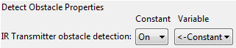
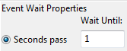
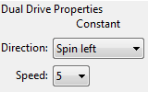
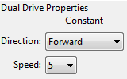
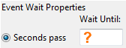

In lesson 3 (Worksheet 3.2), you found the right amount of time to have the robot to turn 180°. Use this time again where indicated above by the orange question mark (?).

What is the correct amount of time to get your robot to turn 180 degrees?
__________

What do you think makes this program incomplete and how could you improve it?
________________________________________________________________________
________________________________________________________________________
________________________________________________________________________
________________________________________________________________________
________________________________________________________________________
www.meetedison.com

Lesson 7 Worksheet 7.4 – Obstacle avoidance
Name: ________________________

Write the following program to have the Edison robot continuously drive avoiding obstacles.
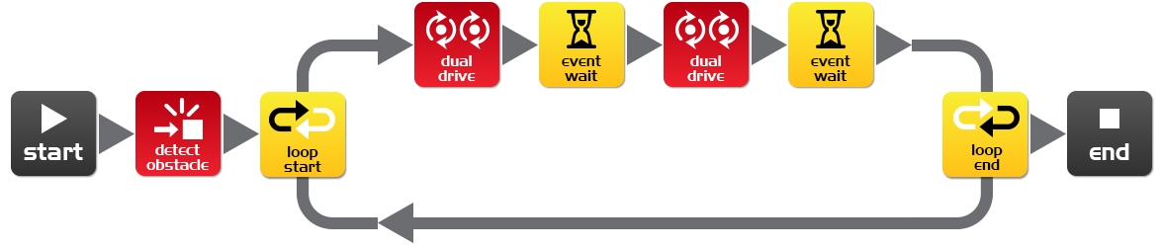
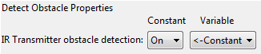
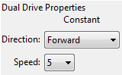
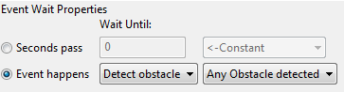
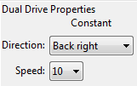
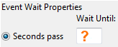

Try experimenting with different amounts of time in the second event wait icon. This time setting determines how long the robot turns for and is indicated above by the orange question mark (?).

What do you think is the best time setting for the robot to turn?
____________

Why is this time setting the best? What does the robot do differently to make it better?
________________________________________________________________________
________________________________________________________________________
________________________________________________________________________

www.meetedison.com

Lesson 7 Worksheet 7.5 – Right and left detection
Name: ________________________
Write the following program to have the Edison robot continuously drive avoiding obstacles to the left and right.
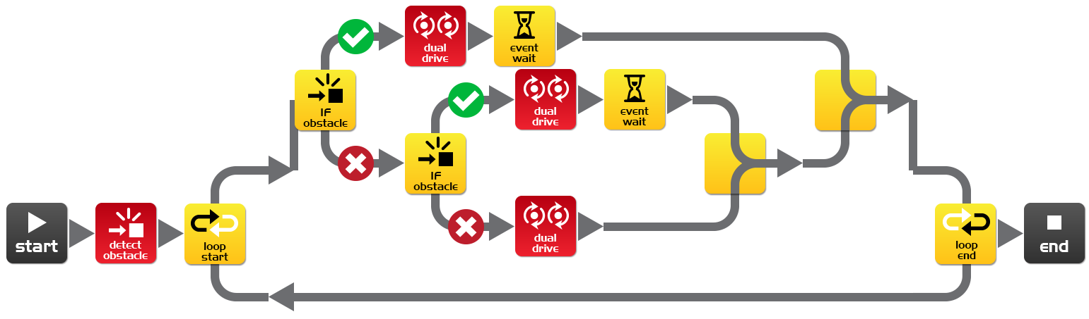
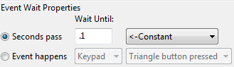
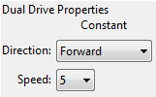
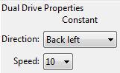
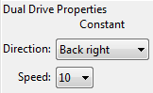
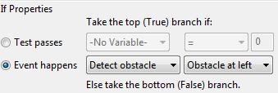
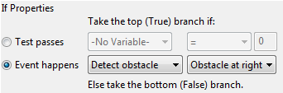

In the above program we are using ‘IF’ icons. These are very important icons, because they give the robot the ability to make decisions without human guidance. When this occurs in a robot it is now called an autonomous robot, as it has artificial intelligence.
An ‘If’ icon asks whether a condition is true or false. If the result is true the program takes the path with a tick. If the result is false the program takes the path with the cross.
The above program has three different paths that it can take based on where an obstacle is. Explain in your own words what these three paths cause the robot to do.
No obstacle detected: ______________________________________________________
Obstacle detected on right: __________________________________________________
Obstacle detected on left: ___________________________________________________
Because the robot can make decisions is it alive!? Why do you think so?
________________________________________________________________________
________________________________________________________________________
________________________________________________________________________
www.meetedison.com

Lesson 8: Line sensing and tracking
Industrial like robotic behaviour – Students learn about basic robot sensing and control similar to that used in advanced automated factories and warehouses.

Understanding the line tracking sensor (Worksheet 8.1)
Students become familiar with the robot’s line tracking sensor and how the robot can detect whether the driving surface is black or white.

Program 1 – Drive until a black line (Worksheet 8.2)
Students write a program that drives the robot until it encounters a black line. They also confirm the questions about the detection of different colours.

Program 2 – Drive inside a border (Worksheet 8.3)
Students write a program that drives the robot inside a border. The line tracking sensor detects the border and the robot turns around. They can use Work sheet 2 or create their own using a large piece of paper and a black marker or black electrical tape on a white desk. As a fun class activity place all the robots inside a large border.

Program 3 – Follow a line (Worksheet 8.4)
Students write a program that follows a black line. They can use Work sheet 2 or create their own track using a large piece of paper and a black marker or black electrical tape on a white desk.

Video – Humans need not apply
Line tracking is a very basic robotic behaviour that is used in many automated factories and warehouses today, but how about in the future. What will the workplace of the future look like with more robots? Will it even exist? The following video will stimulate discussion amongst the class about what the wide spread uptake of robots mean for the future of humans. https://www.youtube.com/watch?v=7Pq-S557XQU (15 minutes)

Lesson 8 Worksheet 8.1 – Line tracking sensor
Name: ________________________

The Edison robot is equipped with a line tracking sensor. The sensor is made up of two main electronic components:
1. Red Light Emitting Diode (LED)
2. Phototransistor (light sensor)
The LED shines light on the surface that the robot is driving on. If you press the round button on Edison twice the LED will come on. By lifting up the robot slightly have a close look at the round spot of light that the LED produces on the surface. Compare how bright the spot of light is when placed on either a black or white surface.
Is the spot brighter (reflects more light) when placed on black or white? ____________
The phototransistor component is a light sensor and measures the amount of light that is reflected from the surface.
LED
Phototransistor
Light from LED
Reflected light
Surface
Cross section of the line tracking sensor

As you saw from the exercise above, there is more light reflected from a white surface than from a black surface. Therefore the phototransistor gives a higher light reading when on a white surface than on a black surface. This allows the robot to be programmed to behave and respond to the surface that it is driving on. A black surface is considered to be ‘non-reflective and a white surface is considered to be ‘reflective’.

How do you think the line tracker would respond to the following surface colours, reflective or non-reflective? (Hint: the light is red)

red surface ____________, green surface____________, blue surface____________
www.meetedison.com

Lesson 8 Worksheet 8.2 – Drive until a black line
Name: ________________________

Write the following program to have the Edison robot drive on a white surface (reflective) until a black line (non-reflective) is crossed.
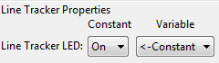
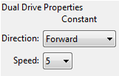
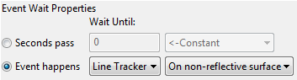

To use the linetracking sensor in a program you must first turn the sensor on. This also activates the red LED.
Use the black line on Activity sheet 8.1 or draw a black line on a piece of white paper. You can also use black electrical tape on a white desk. Drive the robot towards the black line and he will stop.
On Activity sheet 8.1 there are also three coloured lines. These are red, blue and green. Drive Edison towards each of the lines and see if he stops.

Is there a colour that Edison can’t detect (see) very well? Which colour is it? __________

Why do you think this is happening?
________________________________________________________________________
________________________________________________________________________
________________________________________________________________________
www.meetedison.com

Lesson 8 Worksheet 8.3 – Drive inside a border
Name: ________________________

Write the following program to have the Edison robot drive within a border.
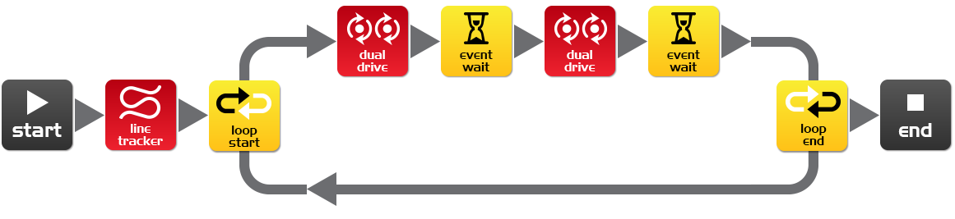
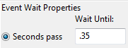
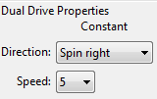

Use Activity sheet 8.2 as a border or create your own using a large piece of paper and a thick black marker.
You can also use black electrical tape on a white desk to create a large border.
If you create a large border try adding lots of robots to see what happens.
Also, experiment with different speeds.

How fast can the robot go before there are problems?
________

What happens when the robot drives too fast?
________________________________________________________________________
________________________________________________________________________
________________________________________________________________________
www.meetedison.com

Lesson 8 Worksheet 8.4 – Follow a line
Name: ________________________

Write the following program to have the Edison robot follow a black line.
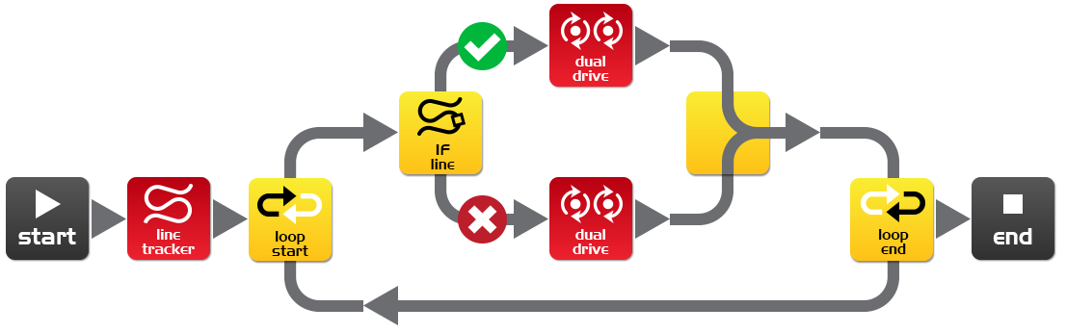
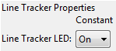
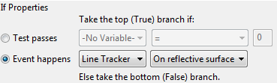
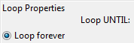
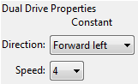
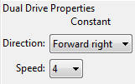

This program uses the ‘IF’ icon to allow the robot to decide what to do. If the line tracking sensor is on a reflective surface (white), then drive forward right at speed 4. If the line tracking sensor is not on a reflective surface, then drive forward left at speed 4. When the robot is on white it drives off white, when the robot is on black it drives off black. As it does this it moves forward and tracks the edge of the line.
Place the robot inside the track on Worksheet 8.2 and watch the robot track the line.
Which way does it travel (clockwise or anti-clockwise)? ____________
Place the robot outside the track on Work sheet 2 and watch the robot track the line.
Which way does it travel (clockwise or anti-clockwise)? ____________
Why do you think the robot doesn’t go in the same direction around the track?
________________________________________________________________________
________________________________________________________________________
________________________________________________________________________
www.meetedison.com

Lesson 8 Activity sheet 8.1 – Line tracking sensor
Name: ________________________
STOP HERE
Use this Activity sheet to test your program from Worksheet 8.2.
You can also confirm your answers from Worksheet 8.1 using the coloured lines below. Which colours does Edison stop for?

STOP HERE?
STOP HERE?
STOP HERE?
www.meetedison.com

Lesson 8 Activity sheet 8.2 – Line tracking sensor
www.meetedison.com
Name: ________________________
Attention!
Start the robot next to the line, not on it.

Lesson 9: Respond to light
Environmental measurement and programming mathematics – Students learn about measuring light levels, storing them in memory and performing mathematics to control the robots behaviour.

Understanding variables (Worksheet 9.1)
Students learn about what a variable is in computing and how to set one up in the Edison robot. They also learn about the two different sized variables; ‘bytes’ (8 bits – 0 to 255) and ‘words’ (16 bits -32,767 to +32,767).

Program 1 – Light level alarm (Worksheet 9.2)
Students write a program that sounds an alarm when the lights in the room are turned on. This program introduces the use of variables and basic mathematics using a ‘greater than’ (>) comparison.

Program 2 – Automatic lights (Worksheet 9.3)
Students write a program that drives the robot forward while monitoring light levels. If the robot drives into a dark area the front lights are automatically turned on. This program uses a ‘less than’ (<) comparison.

Program 3 – Light following (Worksheet 9.4)
Students write a program that drives the robot towards bright light, such as that from a torch/flashlight. This program introduces more computational mathematics, using subtraction and then a ‘less than’ (<) comparison.

Animal behaviours in robotics
The light following program above demonstrates a robot behaviour that is very similar to that of a moth on a warm night being attracted to a street light.
This can make a good discussion about the intelligence of both insects and robots.
Why is an insect that is attracted to light alive, but not a robot?

Lesson 9 Worksheet 9.1 – Understanding variables
Name: ________________________

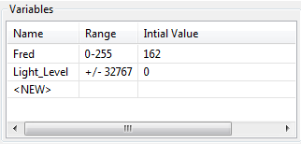
A variable is small piece of computer memory for storing data. What makes variables so useful is that this data can change while the program is running, hence the name variable.
Variables store numbers like 10, 106, 1,482 etc. and allow a computer program to do maths, this is something that computers are very good at.
The Edison robot has two types of variables that are called ‘bytes’ and ‘words’. Byte variables can store numbers that range from 0 to 255. Word variables can store numbers that range from -32,767 to +32,767.
To make variables easy to use we give them names. This helps us humans remember what type of information is stored in them. In EdWare, you can name your variables just about anything you like. You could name one ‘Fred’, but that might not be a very helpful name for remembering what type of information is stored in Fred. A better name might be ‘Light_Level’. This type of name makes it very easy to remember what the variable is used for and what type of data to find there.
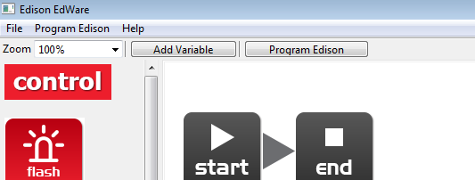
Now that you know about variables let’s create one in EdWare for our next programs.
Add Variable
Click the ‘Add Variable’ button in the top left corner and a pop up box will appear.

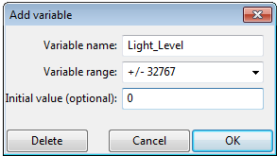
Type in the name of your variable as ‘Light_Level’, select the variable range as +/-32767 (word) and set the initial value to zero. Now click OK and your variable will be added to the variables table in the bottom right corner.

What type of variable would you use for storing the following numbers (byte or word)?

12 _________, 192 _________, 801 _________, -42 _________, 27,901_________
www.meetedison.com

Lesson 9 Worksheet 9.2 – Light alarm
Name: ________________________

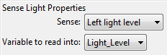
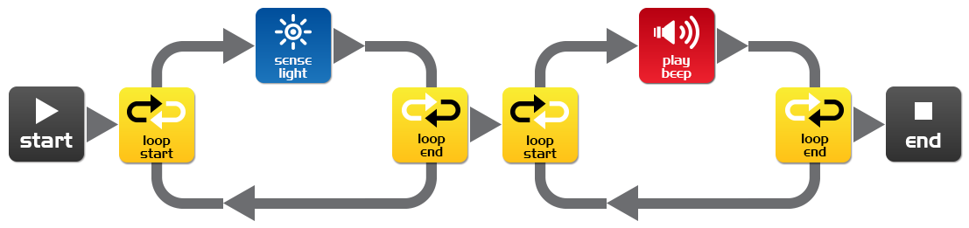
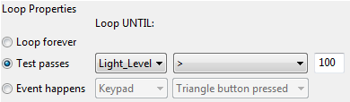
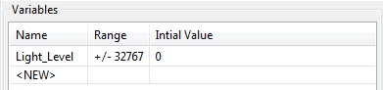
Write the following program to have the Edison robot sound an alarm when the lights in the room are turned on.

The sense light icon reads the light level from the left light sensor and places the reading into the variable called Light_Level.
The first loop uses mathematics to determine what to do.
Loop until the value in the variable called ‘Light_Level’ is ‘greater than’ (>) 100.
When the value in Light_Level is greater than 100 the loop is exited and goes to the next loop that sounds the alarm.
Place the Edison robot in the dark and press the play button. When the lights are turned on, the robot raises the alarm.

Can you think of a real life situation where this type of alarm would be useful?
________________________________________________________________________
________________________________________________________________________
What changes need to be made to the program to make it a dark alarm?
________________________________________________________________________
________________________________________________________________________
www.meetedison.com

Lesson 9 Worksheet 9.3 – Automatic lights
Name: ________________________

Write the following program to have the Edison robot turn the two LED lights on when it gets dark.
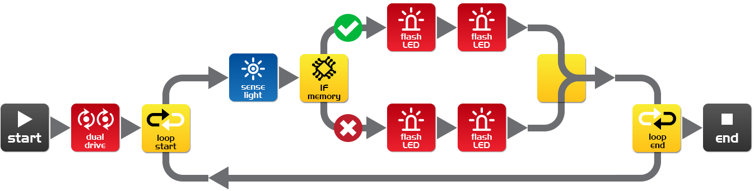
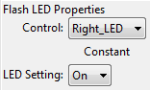
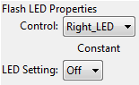
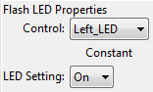
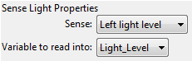
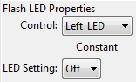
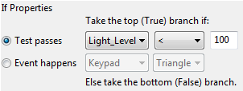
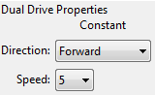

Drive the robot through a tunnel or under a couch and see the front lights come on.
In this program we are using the ‘less than’ (<) symbol to determine the path of the program. If the variable Light_Level is ‘less than’ 100, then take the true path and turn the LEDs on.
Experiment with the value (100) in the If icon.

What happens when you make it higher?
________________________________________________________________________
________________________________________________________________________
What happens if you make it lower?
________________________________________________________________________
________________________________________________________________________
www.meetedison.com

Lesson 9 Worksheet 9.4 – Light following
Name: ________________________
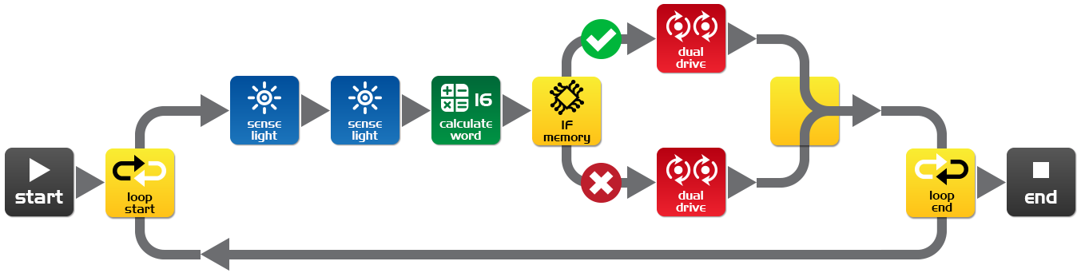
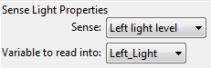
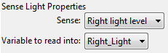
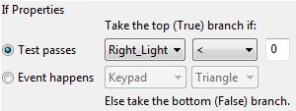
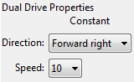
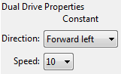
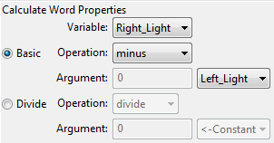
Write the following program to have the Edison robot follow light from a torch/flashlight.

Shine a torch/flashlight at Edison and the robot will drive towards the light.
This program performs a calculation between two variables. In the calculate word icon the variable Right_Light is subtracted from the variable Left_Light. The result (answer) is placed back into the variable Right_Light. Let’s see what the results would look like:
 | Right_Light | Left_Light | Calculation | Result
Torch in right | 200 | 100 | 200 – 100 = | -100
Torch on left | 100 | 200 | 100 – 200 = | +100

From the above you can see that when the torch is to the right the result is below zero (negative number). When the torch is to the left the result is above zero (positive number).
The If icon asks: Is the result less than zero? If true the robot drives left (towards the light), if false the robot drives right (towards the light).
What wold happen if you changed the ‘less than’ symbol (<) to a greater than symbol (>)?
________________________________________________________________________
________________________________________________________________________
www.meetedison.com

Lesson 10: Design brief 2 – My program
Creative thinking and problem solving – This is the second design brief where students come up with their own challenge and conceptualise how the robot can provide a solution This may take two or more lesson periods of 90 minutes, alternatively this can be a home work exercise. Students may select their own topic, state the program’s purpose and explain where the program could be used in the real world. In this design brief students are expected to provide more information than they did in the first design brief. They also now have more programming experience and can use the robot’s sensors.

1. Identify a problem that the robot can solve or action it can take
The students have now watched the ‘Humans need not apply’ video and should be more aware of how robots might be used in the future. This should stimulate new ideas from the students. Some examples are:
- Rescue robot – The robot drives within a border looking for a lost person (mini figure or doll). When the robot locates the person it raises the alarm.
- Driverless car – The robot drives on a designated road (line) without hitting people, other cars or buildings (toys).
- Battle robots – Send robots to war rather than human soldiers. Two robots compete in a sumo competition

2. Describe the problem or the action the robot needs to make
Using the design brief worksheet students describe the problem that their robot program solves and how the robot program solves the problem (solution).
Example: Problem: ‘Human drivers are easily distracted and can make mistakes when driving. These mistakes can be fatal.’ Solution: This program demonstrates how a robot can drive along a road using obstacle detection and can avoid hitting people, other cars or buildings and is therefore much safer.’

3. Write the program and test it
Students write their program and test it.

4. Failure
Inevitably, the first attempt is unsuccessful. Failure is a normal part of programming (or any engineering discipline). The students can describe their failures on the worksheet.

5. Describe the programming icons used and what they do
Using the design brief worksheet 2 students select a number of icons being used in their program and describe what the icon does in the program. Print additional sheets to have students describe more programming icons.

6. Demo
The students demonstrate their robot’s behaviour and talk about their idea, the program, the problems that they encountered and how they solved them.

Lesson 10 Design brief worksheet 10.1 – My program
Name: ________________________
The video ‘Humans need not apply’ provided insight into how robots might be used in the future. Think of a useful task that your robot can perform, and then write a program for it to do that task.
Here are some examples:
- Rescue robot – The robot drives within a border looking for a lost person (mini figure or doll). When the robot locates the person it raises the alarm.
- Driverless car – The robot drives on a designated road (line) without hitting people, other cars or buildings (toys).
- Battle robots – Send robots to war rather than soldiers. Create a sumo ring and program two or more robots to look for each other and then charge to push the other out of the sumo ring

1. Discuss
Discuss this with your partner or other students to decide on a useful robot application that you can program.

What were some of the ideas that came up?
________________________________________________________________________
________________________________________________________________________
________________________________________________________________________
________________________________________________________________________
________________________________________________________________________

What were the reasons why one of the ideas was not feasible?
________________________________________________________________________
________________________________________________________________________
________________________________________________________________________
________________________________________________________________________
________________________________________________________________________
www.meetedison.com

2. Describe
Name: ________________________
Before you start writing your program describe below the problem that your robot is going to solve and how it is going to solve it (solution).
Problem:
________________________________________________________________________
________________________________________________________________________
________________________________________________________________________
________________________________________________________________________
________________________________________________________________________

Solution:
________________________________________________________________________
________________________________________________________________________
________________________________________________________________________
________________________________________________________________________
________________________________________________________________________

3. Write your program
Plan your program before you start to put icons into place. Use the icons that you have learned to use, but you may also try out other icons.

4. Failure?
Not everything works out the way you think it will first time. No sweat! Try again, but first describe what went wrong. Why didn’t your program work first time? Remember this: Thomas Edison famously failed 10,000 times before he successfully invented the light bulb! So, keep trying!
________________________________________________________________________
________________________________________________________________________
________________________________________________________________________
________________________________________________________________________
________________________________________________________________________
www.meetedison.com

Lesson 10 Design brief worksheet 10.2 – My program
Name: ________________________

5. Describe some of the programming icons in your program
Draw and colour in the programming icons below. Then describe what they do in your program.
What is the name of this icon? _____________________
What does this icon do? __________________________
______________________________________________
______________________________________________
______________________________________________
______________________________________________

What is the name of this icon? _____________________
What does this icon do? __________________________
______________________________________________
______________________________________________
______________________________________________
______________________________________________

What is the name of this icon? _____________________
What does this icon do? __________________________
______________________________________________
______________________________________________
______________________________________________
______________________________________________

www.meetedison.com

Student achievement chart
Name: ________________________
Program | Stamp |  | Program | Stamp
2.1 Drive the robot forward |  |  | 7.1 Detect an obstacle and stop
2.2 Drive the robot backward |  |  | 7.2 Detect an obstacle and avoid
2.3 Drive the robot forward and backward |  |  | 7.3 Detect an obstacle and avoid in a loop
2.4 Speed play |  |  | 7.4 Right and left obstacle detection
3.1 Right turn |  |  | 8.2 Drive until a black line
3.2 Left turn |  |  | 8.3 Drive inside a border
3.3 Right and then left turn |  |  | 8.4 Follow a line
3.4 Mini maze |  |  | 9.2 Light level alarm
4.1 Driving challenge |  |  | 9.3 Automatic lights
4.2 Mexican wave robot style |  |  | 9.4 Light following
5 Design brief 1 – My program |  |  | 10 Design brief 2 – My program
6.1 Flash LED in response to clap |  |  | Own program  1.
6.2 Drive in response to a clap |  |  | Own program  2.
6.3 Dance in response to clapping |  |  | Own program  3.

www.meetedison.com
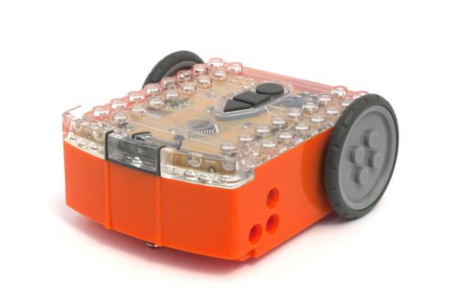
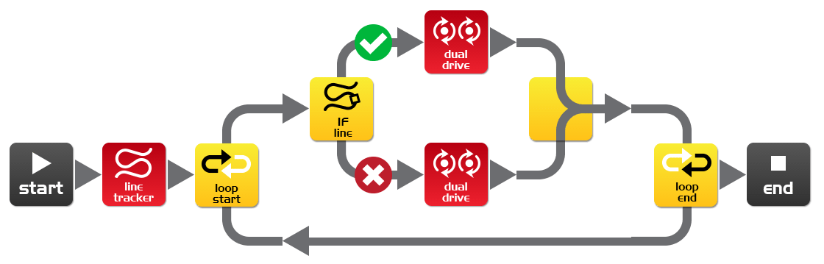

Congratulations

Has successfully completed the
Edison robotics and programming course
The following skills have been achieved:
- Designed, tested and evaluated robot programs using the Edison robot and programming software
- Demonstrated understanding of the robot movement and sensors
- Demonstrated understanding of robot programming principals
- Applied acquired knowledge to design briefs challenges
- Has a wonderful sense of adventure!

www.meetedison.com

