Your EdVenture into Robotics

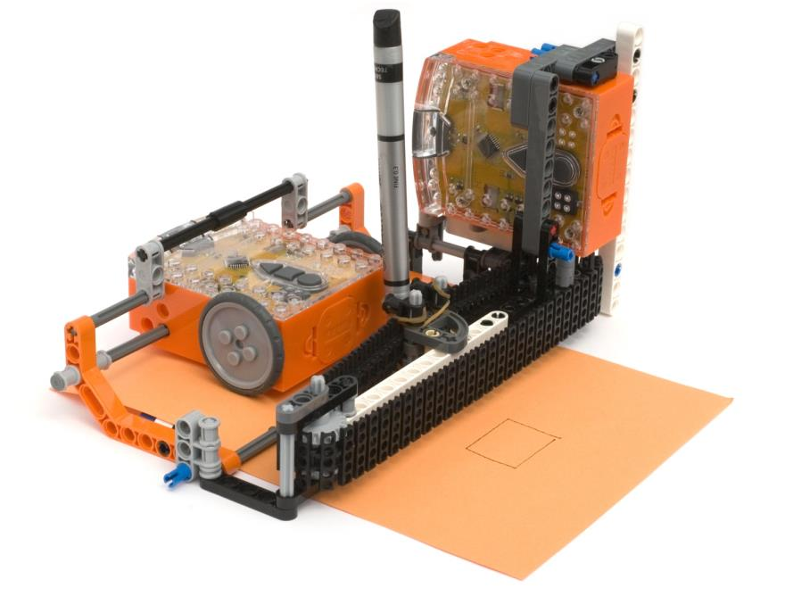
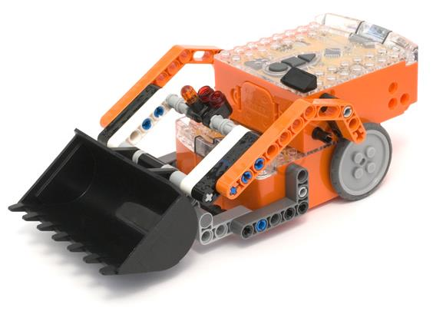
You’re a Builder

meetedison.com

Contents

Introduction 3
Edison and LEGO compatibility 4
EdVenture 1 – The EdDigger 5
EdVenture 2 – The EdPrinter 17
EdVenture 3 – Your EdVenture HERE!! 32

Introduction
EdBook3 ‘You’re a builder’ follows on from EdBook1 and EdBook2, therefore to complete the following EdVentures, it is assumed that both of these EdBooks have been read. And that how to read barcodes and program Edison using EdWare is well understood.

Compact Tracked Loader
The EdVentures in this EdBook use parts from the LEGO Compact Tracked Loader (set 42032). This LEGO set is available from shop.lego.com or your local LEGO retailer.
It’s a great LEGO set and it is recommended that the model on the front cover is built before starting the EdVentures.

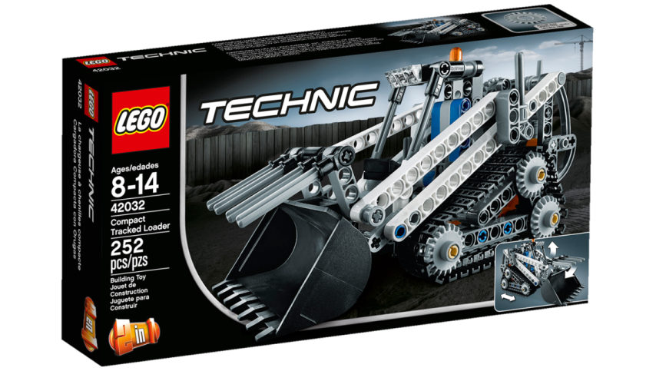

Edison and LEGO compatibility
LEGO bricks can be attached to the top and bottom of the Edison robot and LEGO pegs can be attached on the sides. There are three types of holes on the side of Edison:
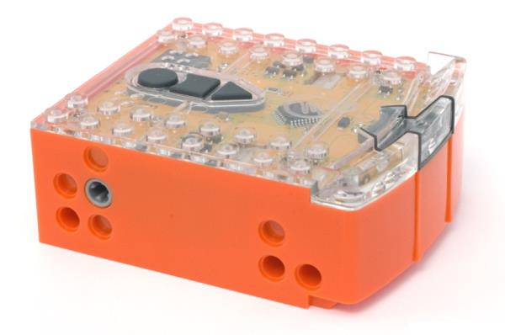
stud hole
stud hole
stud hole
pin hole
powered cross axle socket
2 x pin holes
stud hole
2 x 8 studs
2 x 8 studs
Edison’s side and top LEGO connections

Hole type | Description | Connects to
Pin hole | Full depth for connecting pegs | 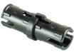
Stud hole | Normal stud depth can be used for half pegs | 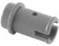
Cross axle | Powered output that rotates | 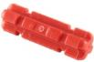
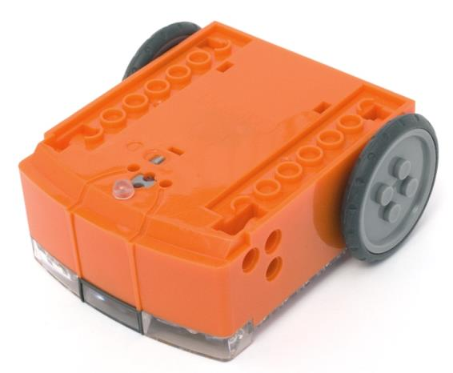
2 x 8 sockets
2 x 8 sockets

Removable skid
2 x 2 studs

Edison’s bottom and wheel LEGO connections

EdVenture 1 – The EdDigger
The EdDigger is a remote control LEGO brick digger that uses two Edisons connected with LEGO pieces from LEGO set 42032. You can use a standard TV/DVD remote control to drive the EdDigger and operate the bucket.

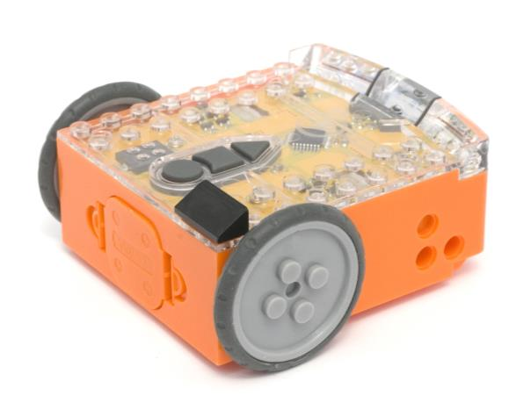

Program the remote control codes
Print the next two pages so you can drive the two Edison robots over the barcodes.
To make this process easier mark one Edison with the black sloping roof tile piece as shown. This Edison will be used as the bucket controller.

Program bucket controller Edison
Drive the marked Edison over the following barcodes. Use buttons that correspond well with bucket up and bucket down on the remote control, but don’t use the buttons that you want to drive the EdDigger with. See suggested button arrangement below, although your remote control will likely be different.

Reading the barcode
1. Place Edison facing the barcode on the right side
2. Press the record (round) button 3 times
3. Edison will drive forward and scan the barcode
4. Press a button on your TV/DVD remote that you want to activate that function

Barcode – IR learn bucket up
Barcode – IR learn bucket down

Suggested button setup
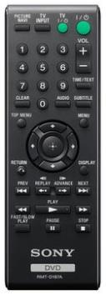
bucket up

bucket down

drive forward

spin right

spin left

drive backward

Program driving Edison
The driving Edison will control the movement of the EdDigger (forwards, backwards, spin left and spin right). Drive this Edison over the following barcodes. Use buttons that correspond well with the driving manoeuvres on the remote control, but don’t use the buttons that you want to control the bucket with.

Reading the barcode
1. Place Edison facing the barcode on the right side
2. Press the record (round) button 3 times
3. Edison will drive forward and scan the barcode
4. Press a button on your TV/DVD remote that you want to activate that function

Barcode – IR learn drive backward
Barcode – IR learn drive forward

Barcode – IR learn spin left
Barcode – IR learn spin right

Assemble the EdDigger
Follow the illustrations to build the EdDigger.

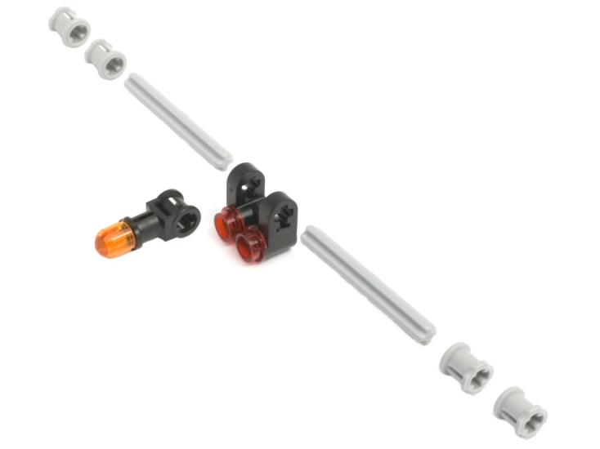
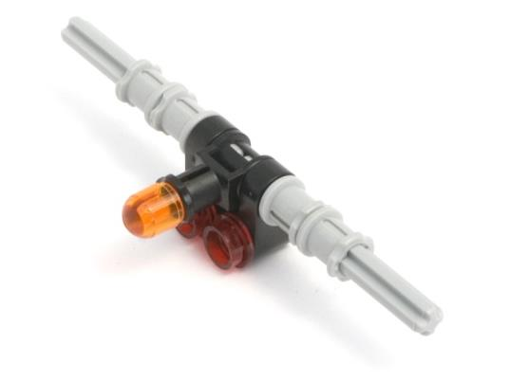
Loader brace

Bucket assembly
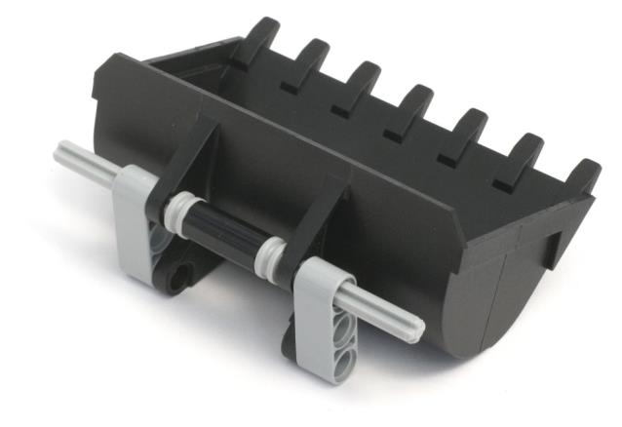

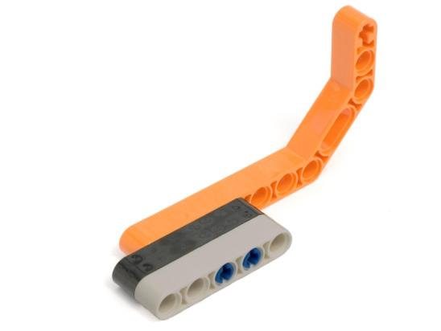
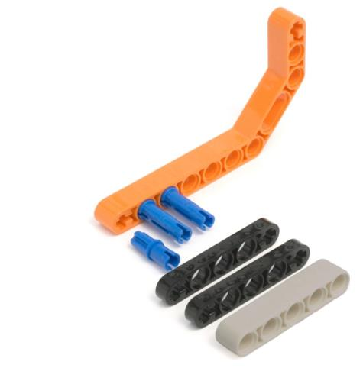
Left lift arm

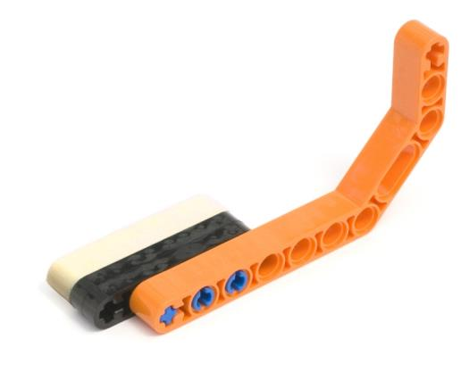
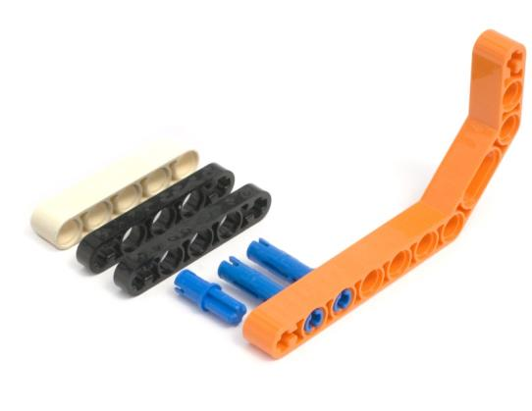
Right lift arm

Lift assembly
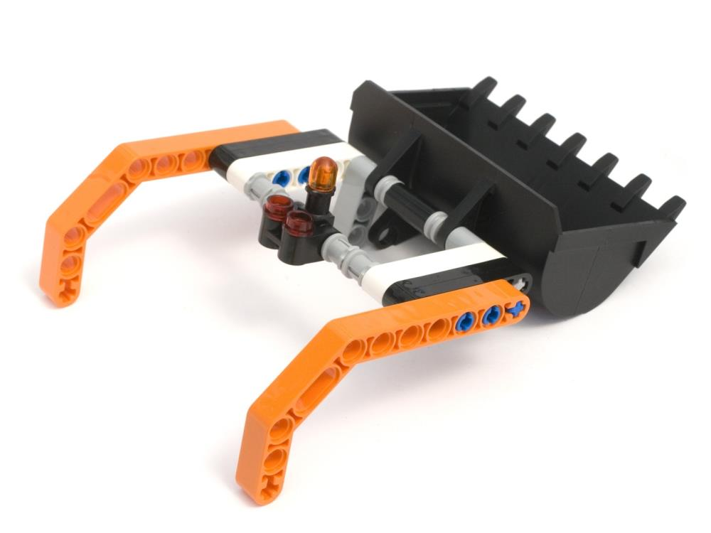

Lift leavers (x2)
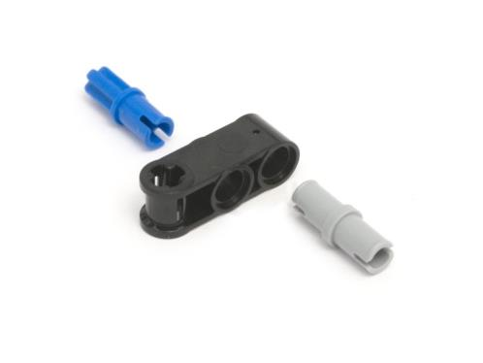
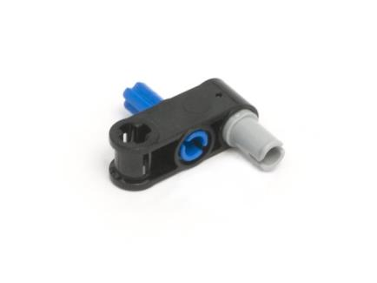

Attach lift leavers and limiters (top Edison)
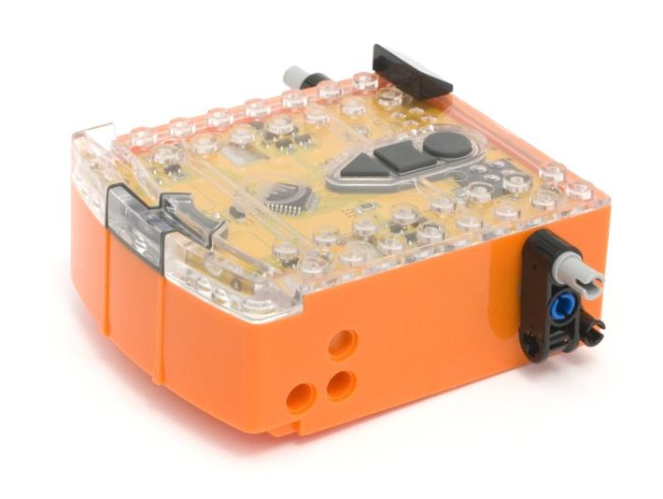
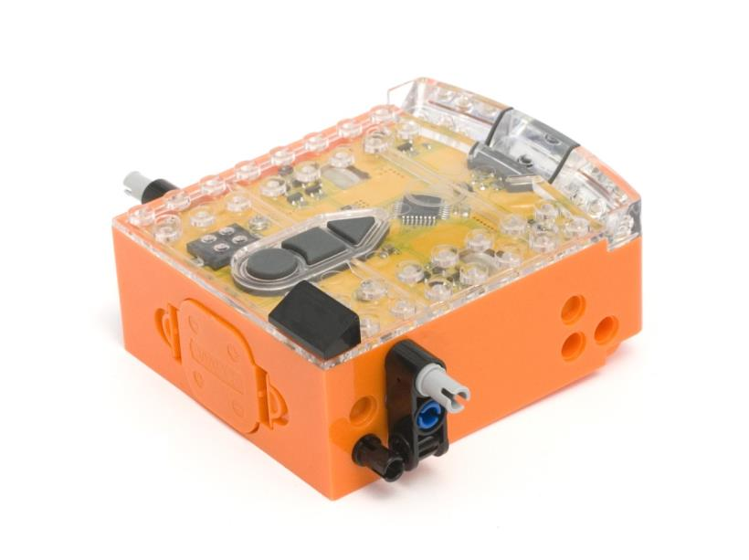

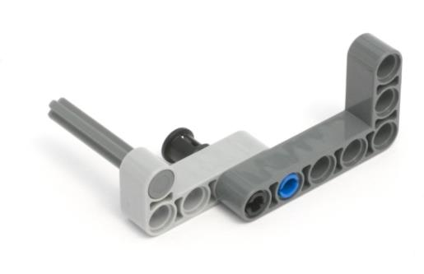
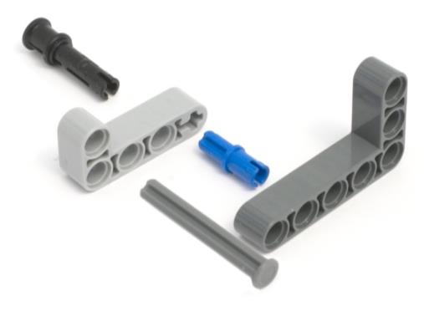
Left support arm

Right support arm
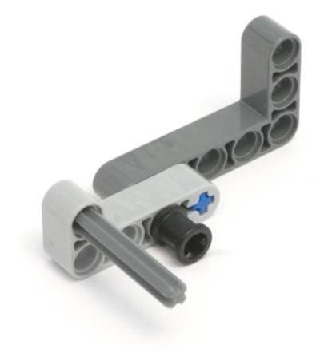
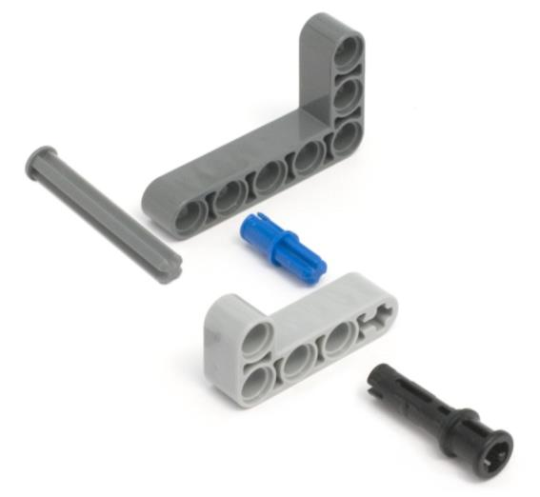

Attach right support arm
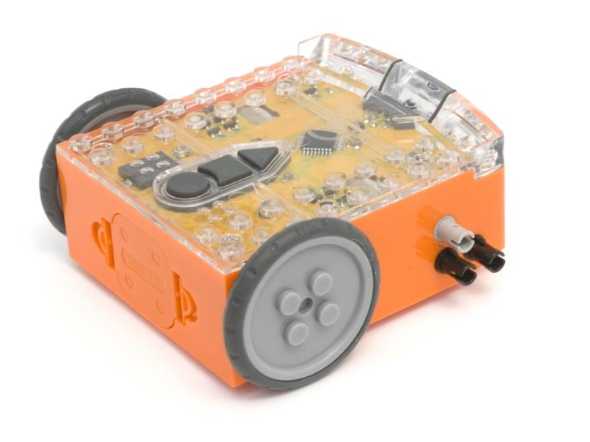
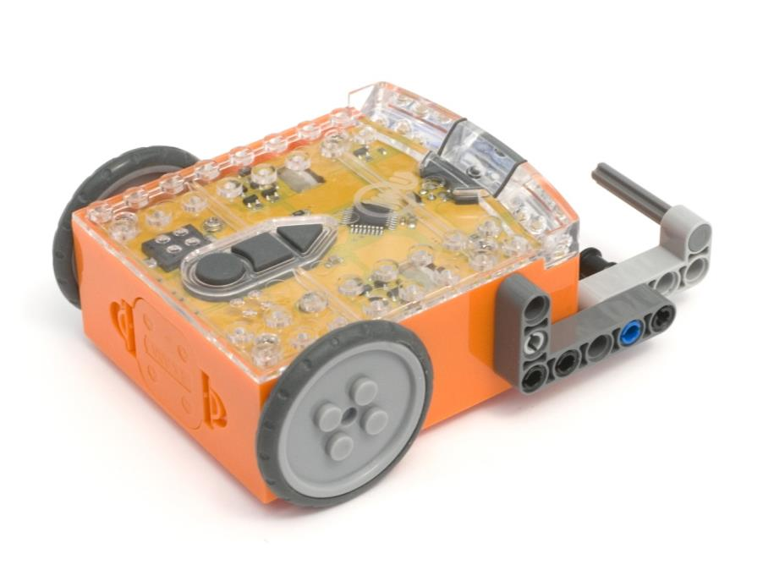

Attach left lift arm and loader assembly
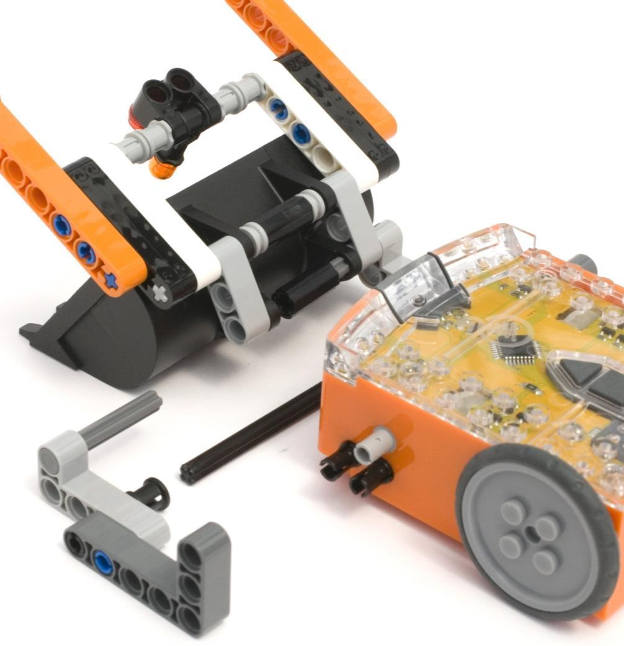
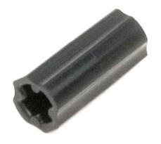

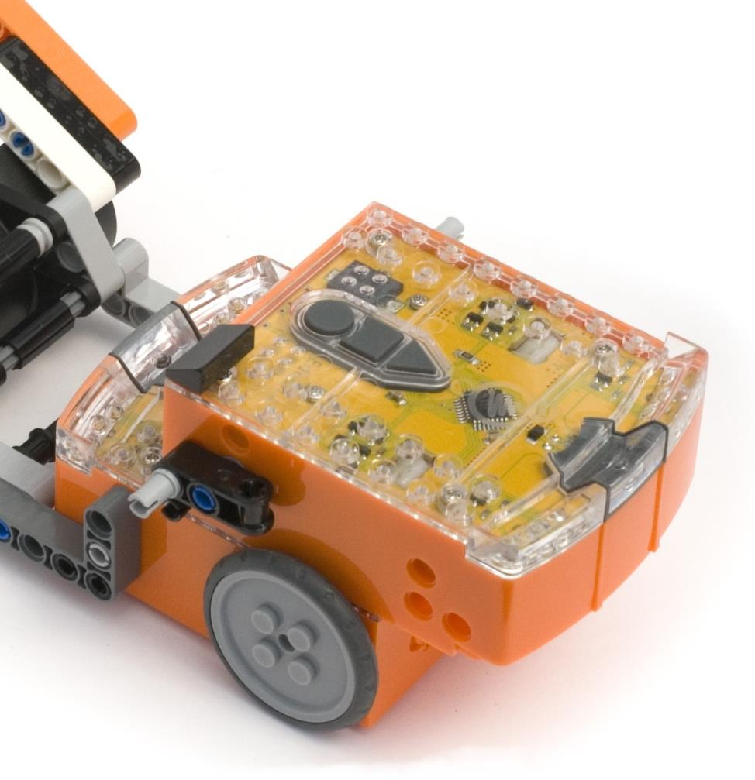
Attach top Edison robot
2 LEGO studs back
2 LEGO studs back

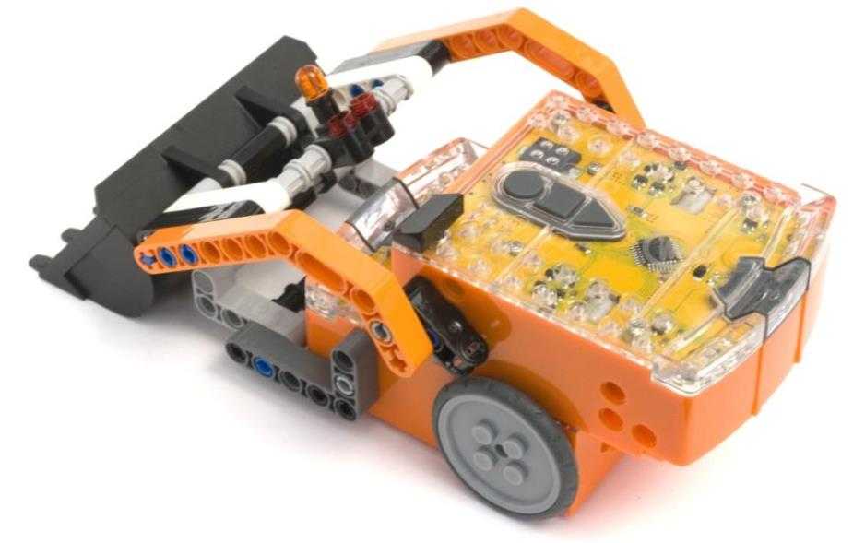
Attach lift arms to leavers

Assembly complete – Get to work!

EdVenture 2 – The EdPrinter
The EdPrinter is a simple printer that can draw shapes on A5 (5.8in x 8.3in) size paper. The printer uses two Edisons connected with LEGO pieces from LEGO set 42032, two rubber bands and a felt tip/marker pen.
Both Edisons are programmed using EdWare, but they perform slightly different functions.

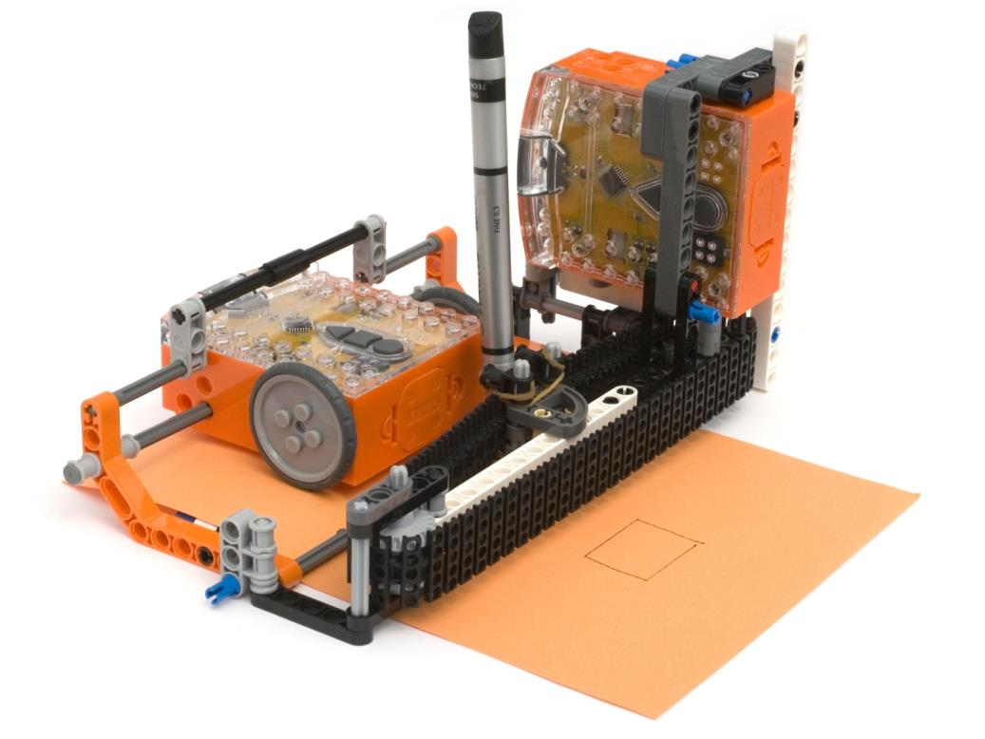
Pen controller Edison

Paper feeder Edison

Paper feeder
The paper feeder Edison uses its wheels to move the paper back and forth. It receives infrared commands from the pen controller that tell it when to move the paper.

Pen controller
The pen controller Edison moves the pen side to side via a gear and belt/track. The shape that the EdPrinter draws is programmed in the pen controller.
Download the programs here EdPrinter programs and program each Edison accordingly.

Building the EdPrinter
The EdPrinter is an advanced project and requires a high level of LEGO building skills. As the EdPrinter uses some non-LEGO compatible parts (rubber bands and pen) some fine-tuning is also required.

Clutch drive gear
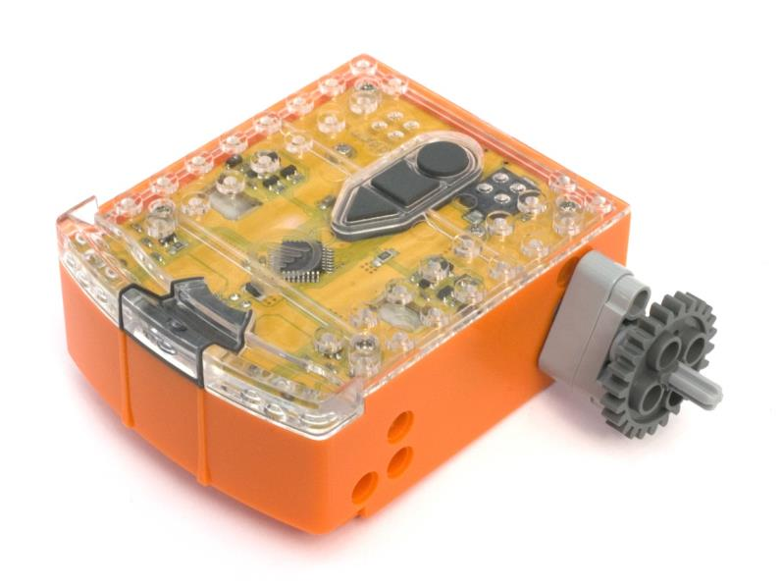
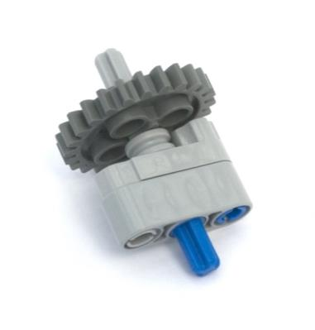
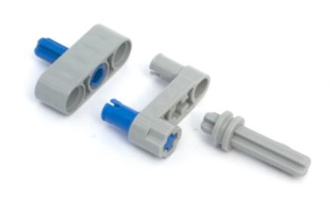
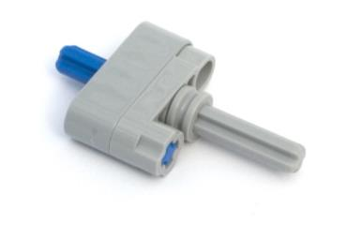

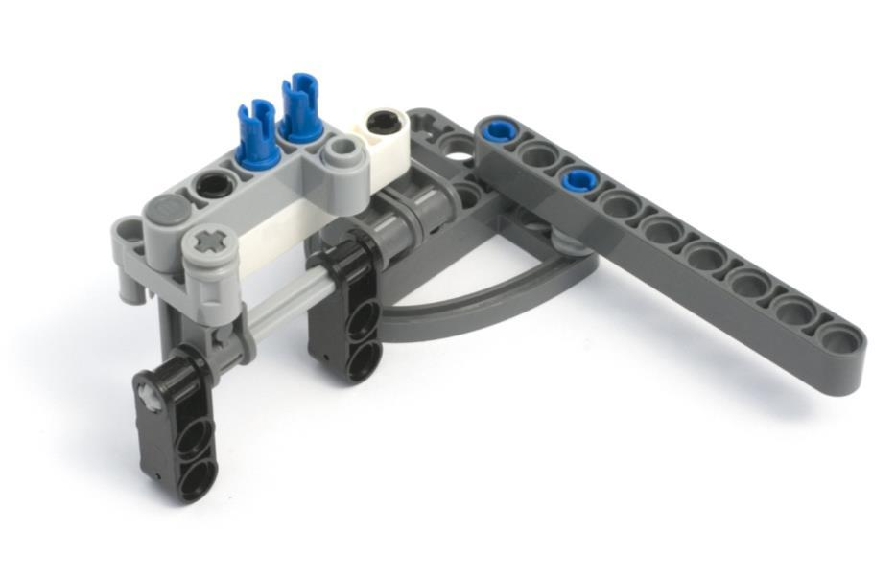
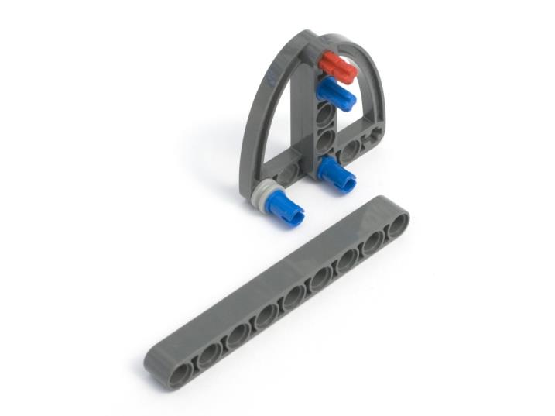
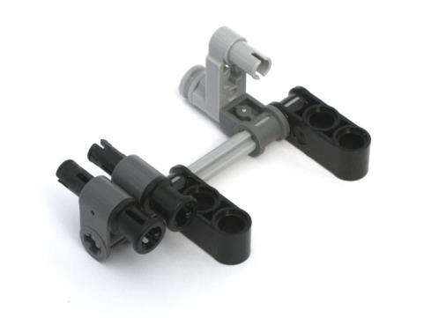
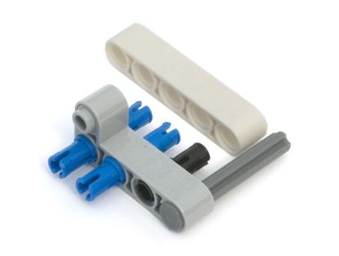
Base
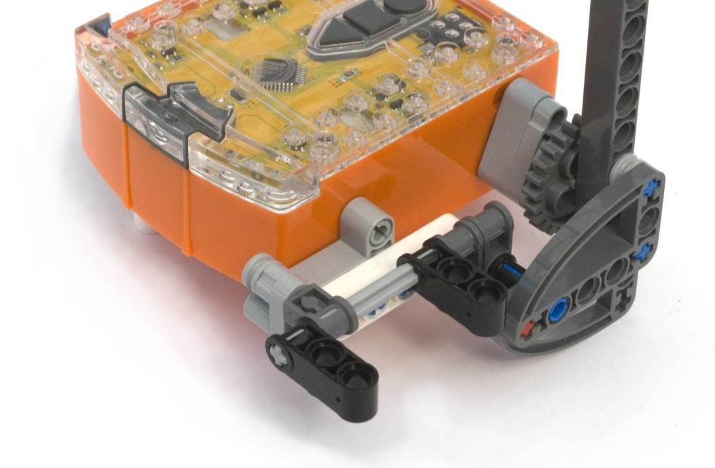

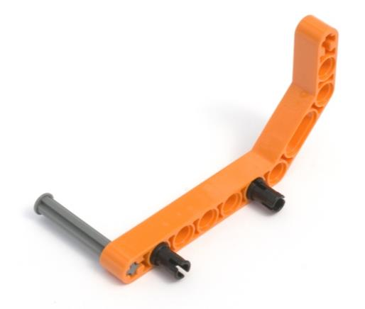
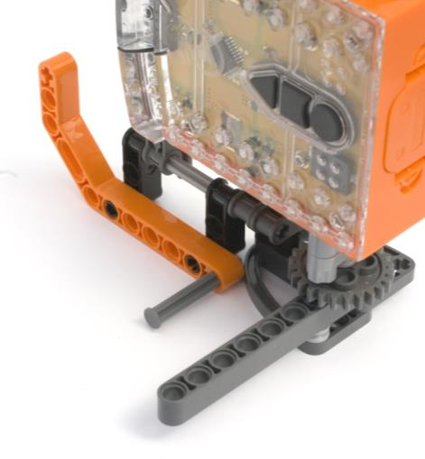
Paper guide

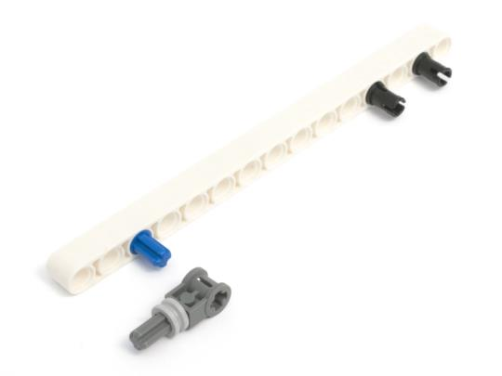
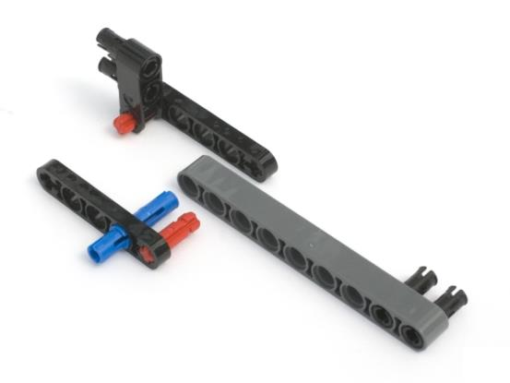
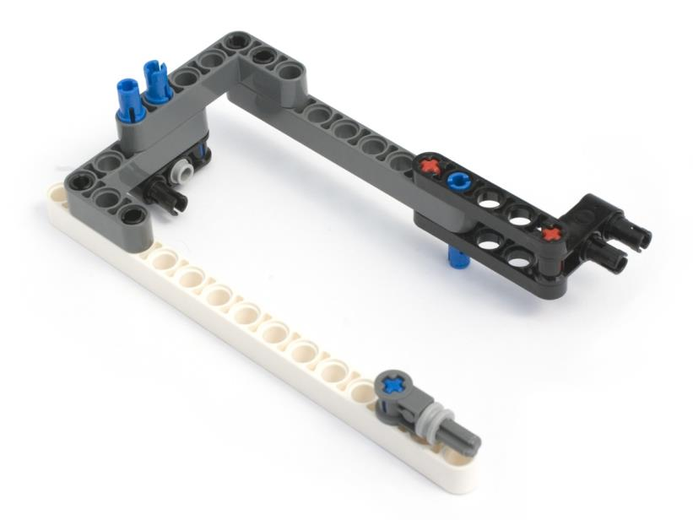
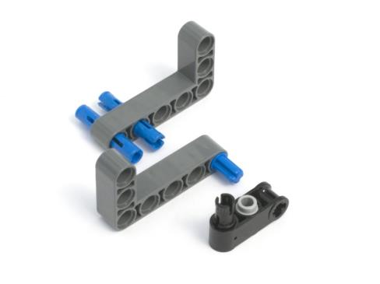
Frame

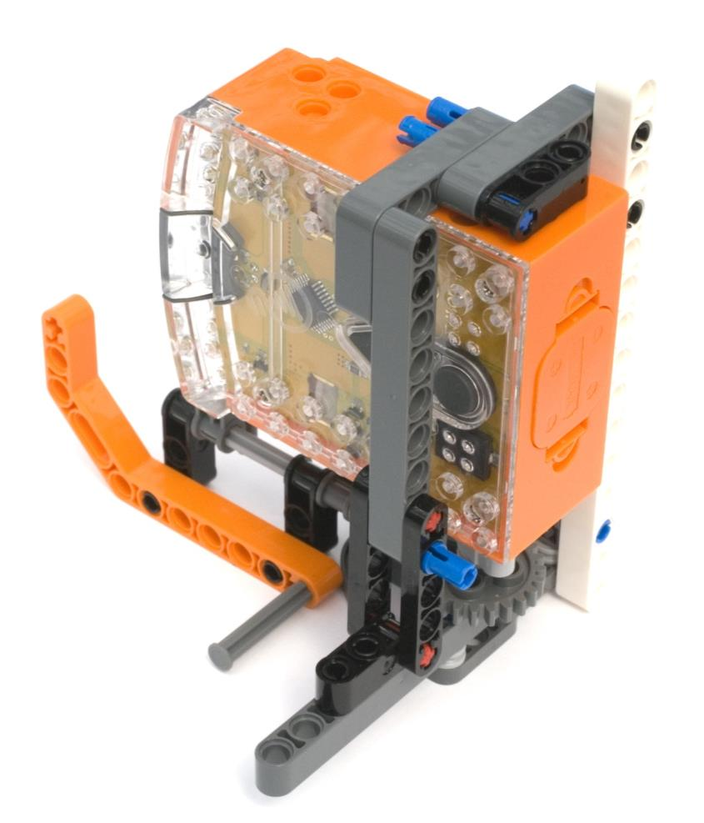
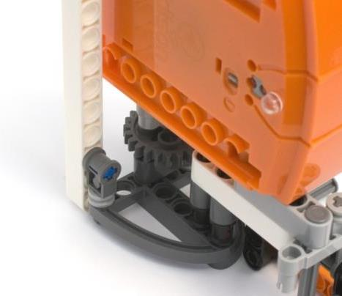

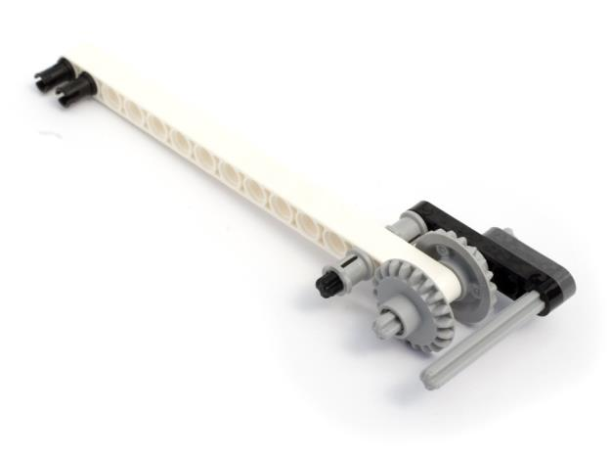
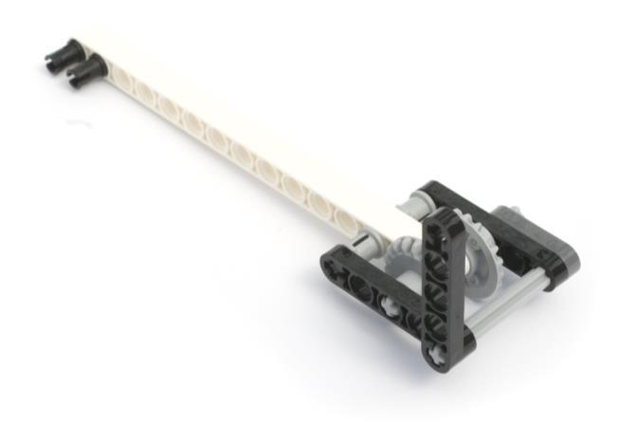
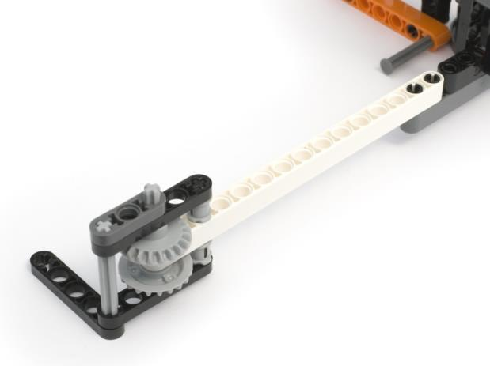
Pen arm

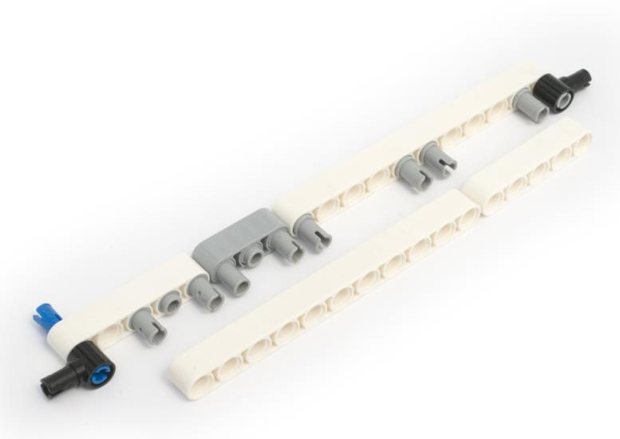
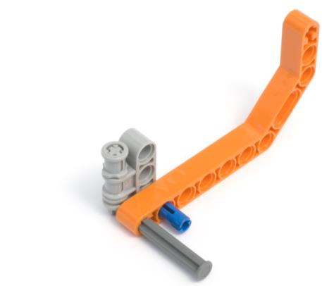
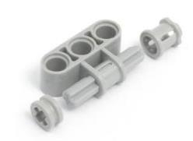
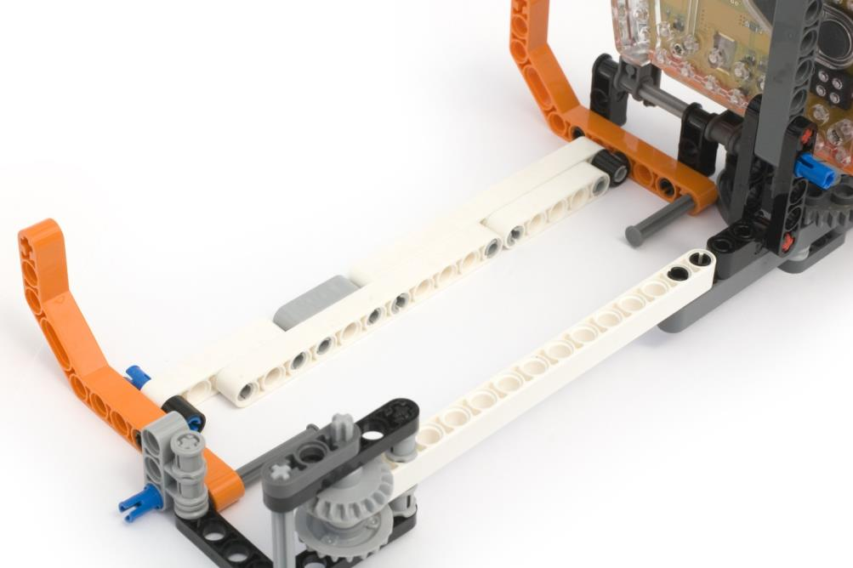
Paper runner

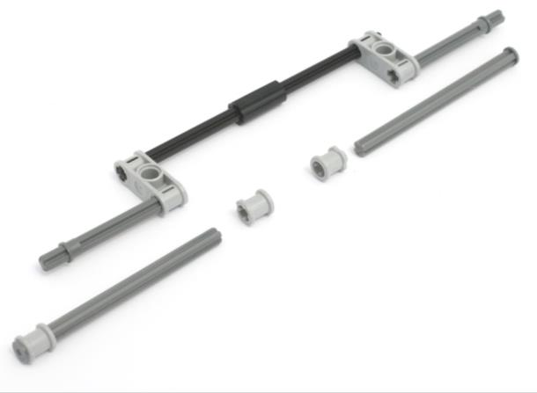
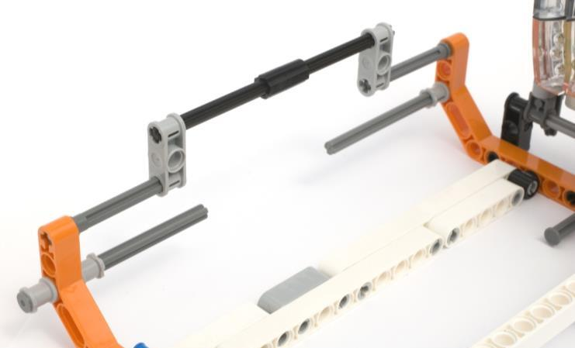
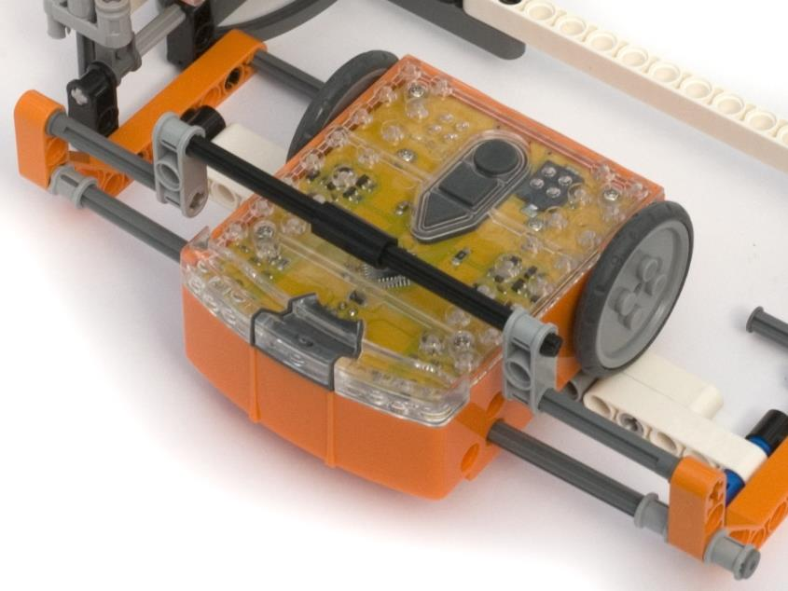
Paper feeder support

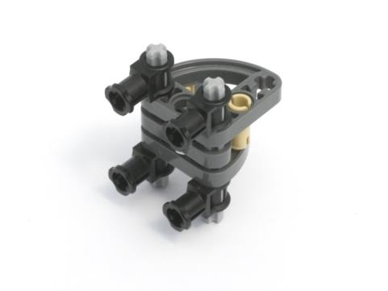
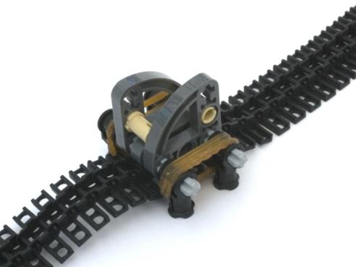
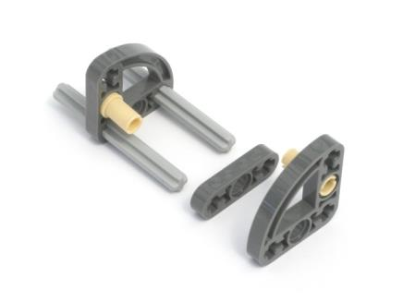
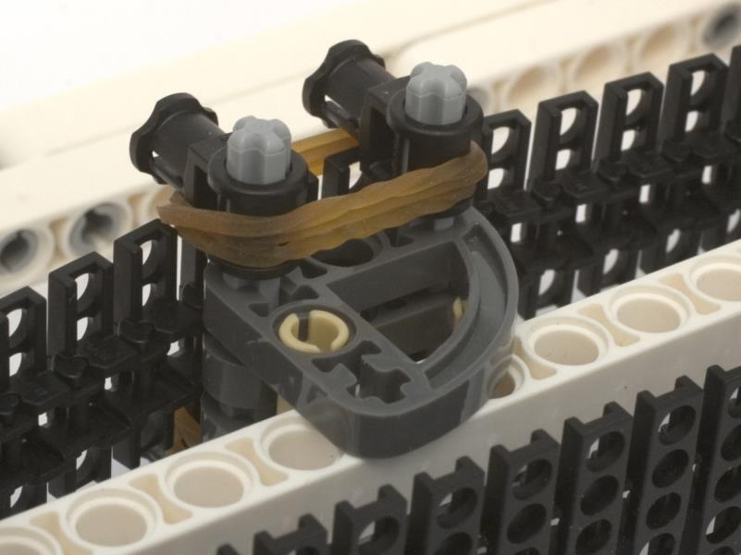
Pen holder
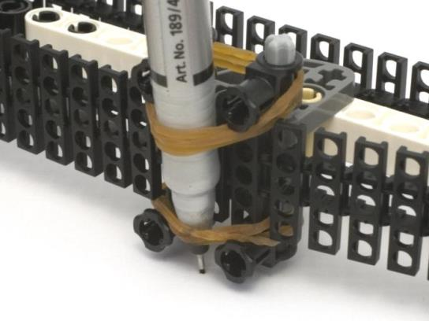
To fit the felt tip pen or marker, slide it under the two rubber bands. Some adjustment will be needed to get the pressure on the paper just right.

Assembly complete
Cut a piece of A4 paper in half (A5 - 8.27in x 5.83in) and then while lifting the paper feeder Edison slide the paper into position.
Position the pen close to the pen controller Edison. Press the play button on the paper feeder Edison first and then press play on the pen controller Edison. Your EdPrinter will now print a square.
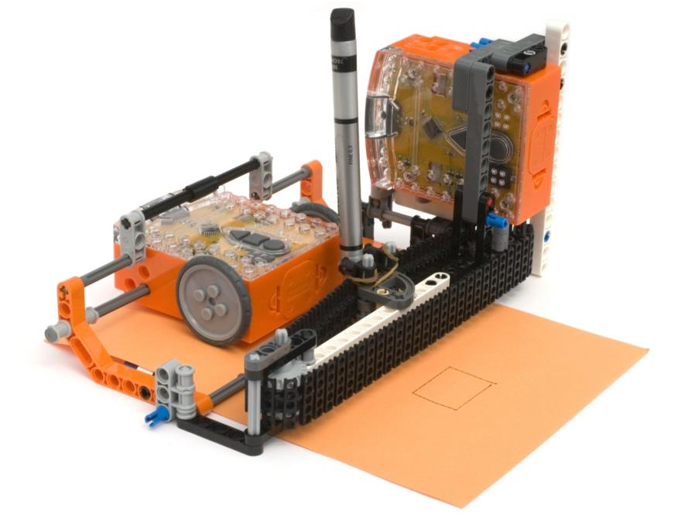

Paper feeder program
The paper feeder program can be downloaded here: EdPrinter programs.

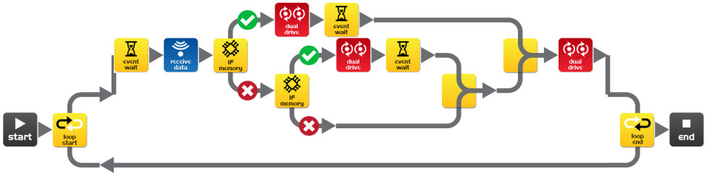
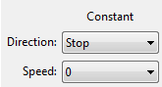
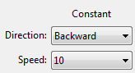
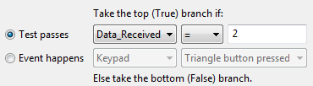
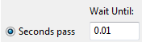
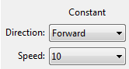
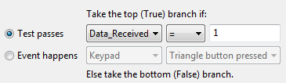
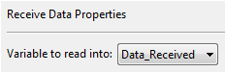
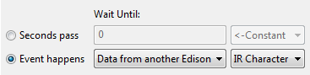
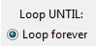

How it works
The program enters a loop and waits for infrared (IR) data from the pen controller Edison.
When IR data is received the receive data icon moves the data into a variable called ‘Data_Received’. The first If icon tests if the received data is equal to 1, if yes, then the dual drive icon moves the wheels forward for .01 seconds (event wait icon). This causes the paper to feed out of the EdPrinter. If the data is not equal to 1, then the second If icon tests if the received data is equal to 2, if yes, then the dual drive icon moves the wheels backward for .01 seconds (event wait icon). This causes the paper to move back into the EdPrinter.
To create your own printed shapes you can use this program without making any changes. The program in the pen controller Edison is the only program that needs to be changed.

Pen controller program
A sample pen controller program that draws a square can be downloaded here: EdPrinter programs.
Move pen
Move pen
Move paper
Move paper
side 1
side 2
side 3
side 4

This program is made up of four parts, one for each side of the square that it draws. First we move the pen (side 1), then move the paper (side 2), then we move the pen (side 3) and finish with moving the paper (side 4).
Moving the pen draws a horizontal line and moving the paper draws a vertical line.
More complex shapes can be drawn by adding pen and paper movements. You can also control the length of the lines. However, as there is no way to lift the pen all shapes will be made from a continuous line.

Draw a horizontal line (move pen)
This is a loop from the above program that moves the pen to draw a horizontal line.

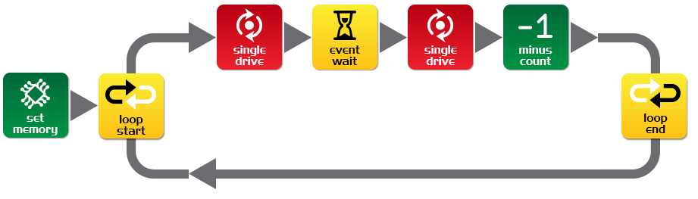
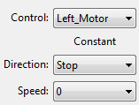
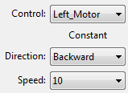
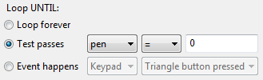
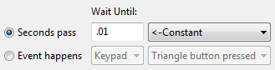
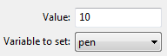

How it works
The set memory icon puts the value 10 into the variable named ‘pen’. The program then enters a loop. The loop is set to end when the value in the variable ‘pen’ is equal to zero. As the value in ‘pen’ is not zero the loop starts.
The first icon in the loop is the single drive icon and sets the direction that the pen moves. This moves the pen for 0.01 of a second, which is set by the event wait icon and the next single drive icon. The minus count icon subtracts 1 from ‘pen’ and the loop again tests whether ‘pen’ equals zero. This loop will repeat 10 times until ‘pen’ is equal to zero. The program will then move on.
The value that is put into ‘pen’ before the loop starts determines how long the line will be. In this program the pen moves 10 times. Each movement of the pen is about 2.5mm (0.1 inches), so our line is about 2.5cm (1 inch) long.
The direction of the pen is set by whether the single drive icon is set to Backwards or Forwards.

Draw a vertical line (move paper)
This is a loop from the above program that moves the paper to draw a vertical line.

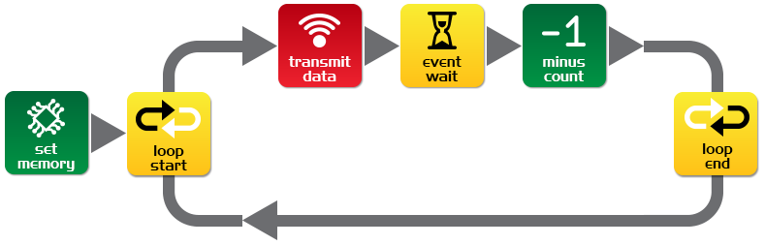
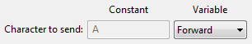
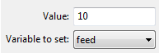
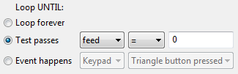
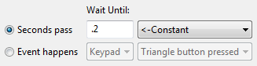

How it works
The set memory icon places the value 10 into the variable called ‘feed’. The program then enters a loop, providing that ‘feed’ is not equal to zero. As 10 has just been placed into ‘feed’ then the program will loop.
The first icon in the loop is the transmit data icon. This icon sends the data held in the variable called ‘forward’ (1) via infrared. This is received by the paper feed Edison and the paper feeds forward. The wait icon pauses the program for 0.2 seconds. This allows the infrared data enough time to finish transmitting. The minus count icon subtracts one from the ‘feed’ variable. After the program has looped 10 times ‘feed’ will equal zero and the program will leave the loop.
The value that is put into ‘feed’ before the loop starts determines how long the line will be. In this program the paper moves 10 times. Each movement of the paper is about 2.5mm (0.1 inches), so our line is about 2.5cm (1 inch) long.
The direction of the paper feed is set by whether the variable ‘forward’ (1) or the variable ‘backward’ (2) is transmitted.

EdVenture 3 – Your EdVenture HERE!!

We want to hear about your own EdVentures and amazing creations, so we are asking for submissions for the third EdVenture.
The winner that has their Edventure published in EdBook3 will receive recognition and win 10 Edison robots!
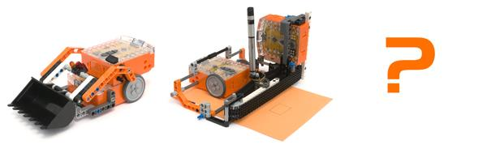
EdVenture 1

EdVenture 2

EdVenture 3

Conditions of entry

1. Use one or more Edison robots
2. Use LEGO parts only from the Compact Tracked Loader (set 42032)
3. Provide a photo and description of your creation

The most awesome entry will be chosen as the winner.
Oh, and you can enter as many times as you like until the competition closes on June 30 2015.

Submit your entry
Complete the online form here:
www.meetedison.com/edbook3-competition

LEGO (R) is a registered trademark of The LEGO Group

